ĐẠI HỌC BÁCH KHOA HÀ NỘI  
 TRƯỜNG CÔNG NGHỆ THÔNG TIN VÀ TRUYỀN THÔNG

BÁO CÁO THỰC HÀNH  
 **IT3103-744527-2024.1**

BÀI THỰC HÀNH 05

Họ và tên sv: **Trịnh Hữu An**  
Lớp: **Việt Nhật 03 – K67**

GVHD: **Lê Thị Hoa**

TA: **Đặng Mạnh Cường**

Hà Nội 12/2024

Table of Contents

1. Swing components 4

1.1 AWTAccumulator 4

1.2 SwingAccumulator 6

2 Organizing Swing components with Layout Managers 8

2.1 Code 8

2.2 Demo 10

3 Create a graphical user interface for AIMS with Swing 12

3.1 Create class StoreScreen 12

3.2 Create class MediaStore 15

3.3 Demo 17

4 JavaFX API 20

4.1 Create class Painter 20

4.2 Create Painter.fxml 20

4.3 Create class PainterController 22

5 View Cart Screen 26

5.1 Create cart.fxml 26

5.2 Create class CartScreen 29

5.3 Create class CartScreenController 31

5.4 Demo 34

6.1 Edit class CartScreenController 35

6.2 Demo 36

7 Deleting a media 37

7.1 Code 37

7.2 Demo 37

8 Complete the Aims GUI application 38

9 Use case Diagram 45

10 Class Diagram 46

Table of Figures

Figure 1.1: Source code of AWTAccumulator 4

Figure 21.2: Demo of AWTAccumulator 6

Figure 3: Source code of NumberGrid 9

Figure 4: Demo NumberGrid 12

Figure 5: Class StoreScreen 15

Figure 6: Class MediaStore 16

Figure 7: Demo 19

Figure 8: Class Painter 20

Figure 9: Painter.fxml 21

Figure 10: PainterController 22

Figure 11: Use pen 23

Figure 12: Use eraser 24

Figure 13: Clear Button 25

Figure 14: cart.fxml 28

Figure 15: Create CartScreen 30

Figure 16: Create CartScreenController 33

Figure 17: Demo 34

Figure 18: Edit class CartScreenController 35

Figure 19: Demo 36

Figure 20: btnRemovePressed method 37

Figure 21: Demo 38

Figure 22: Store before add book 39

Figure 23: Add book 39

Figure 24: Store after add book 39

Figure 25: Add CD 40

Figure 26: Store after add CD 40

Figure 27: Add DVD 41

Figure 28: Store after add DVD 41

Figure 29: Add to Cart 43

Figure 30: Cart 43

Figure 31: Exception 44

Figure 32: Use case diagram 45

Figure 33: Class Diagram 46

# Swing components

## AWTAccumulator

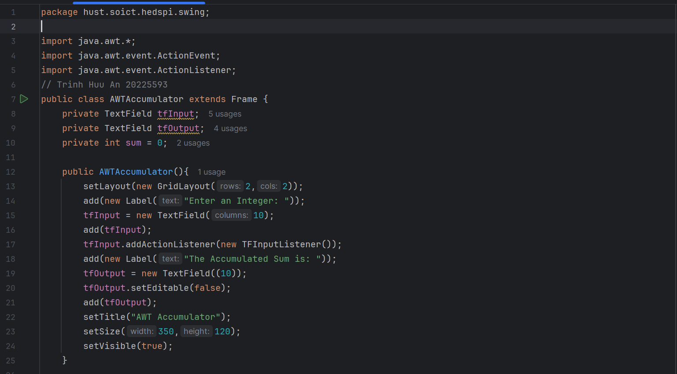

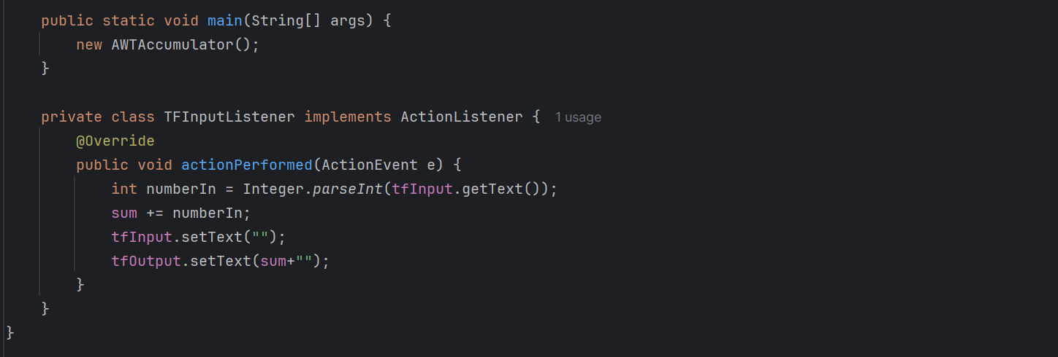

Figure .1: Source code of AWTAccumulator

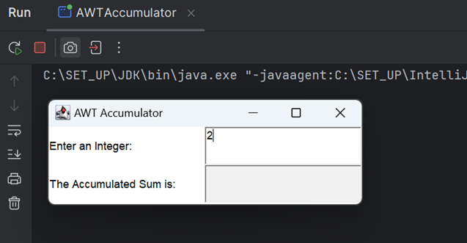

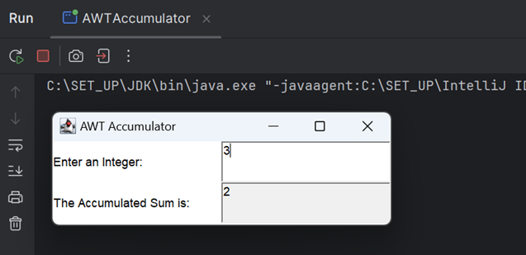

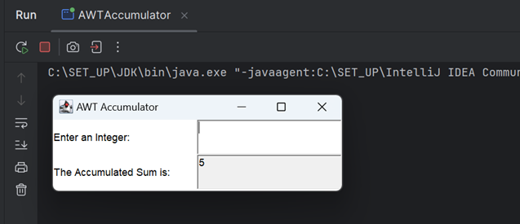

Figure 1.2: Demo of AWTAccumulator

## SwingAccumulator

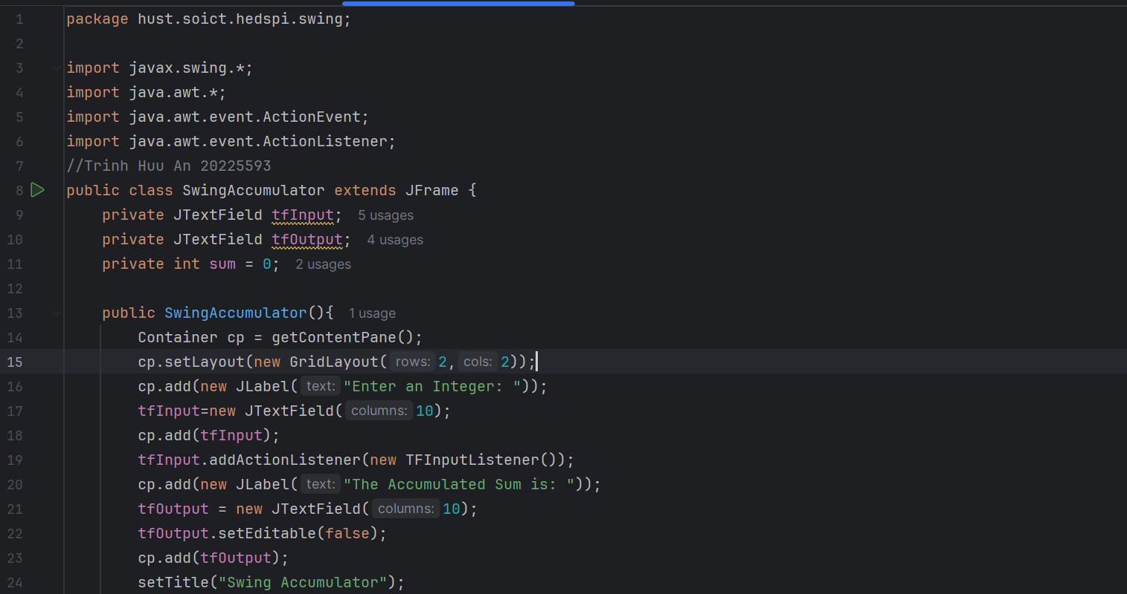

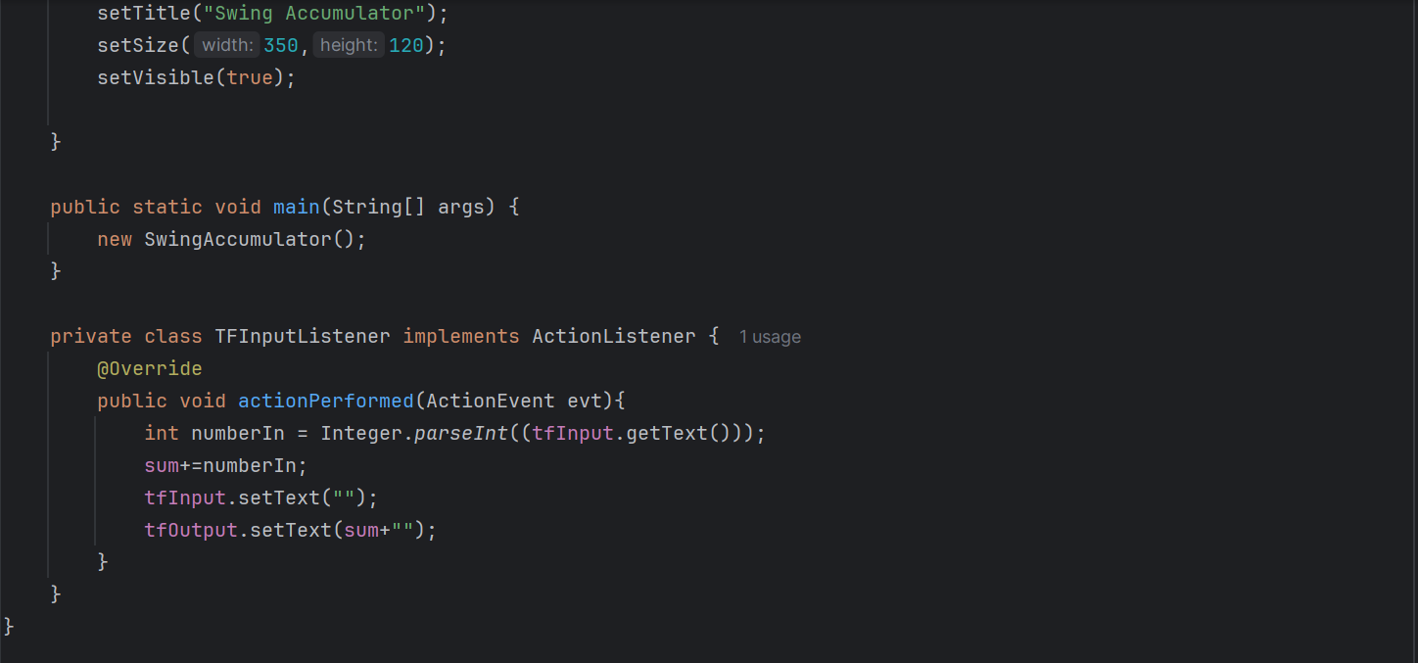

Figure 1.3 : Source code of SwingAccumulator

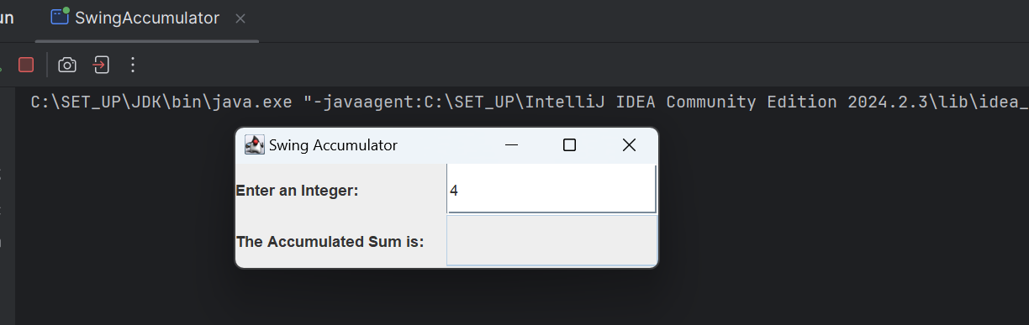

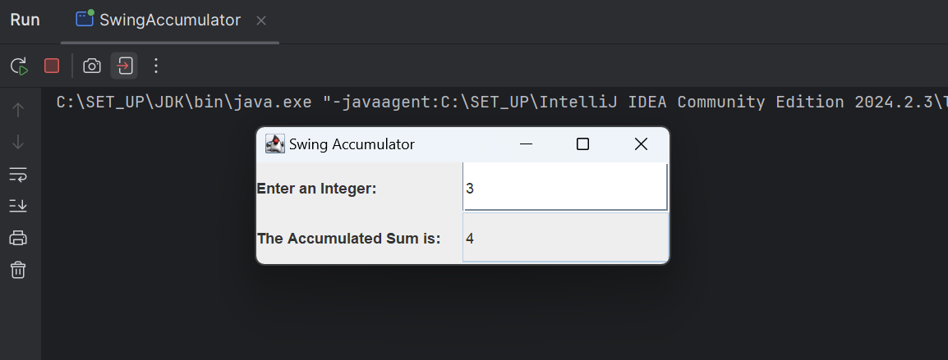

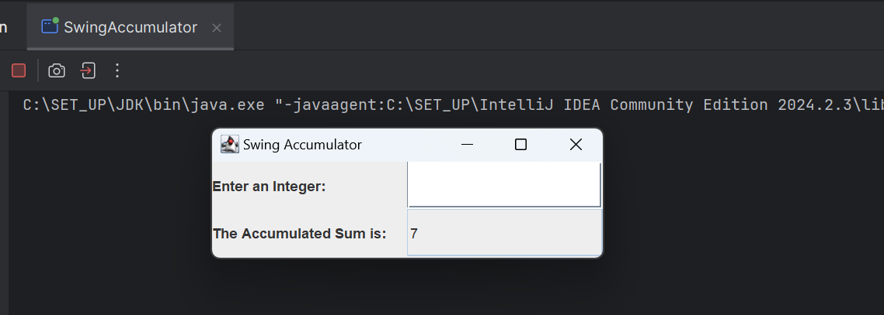

Figure 1.4: Demo of SwingAccumulator

# Organizing Swing components with Layout Managers

## Code

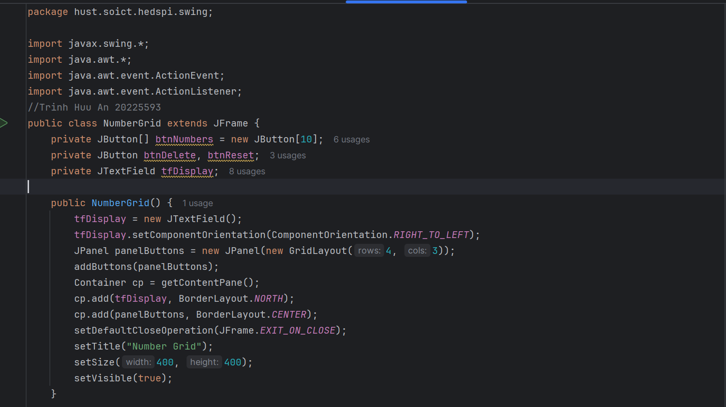

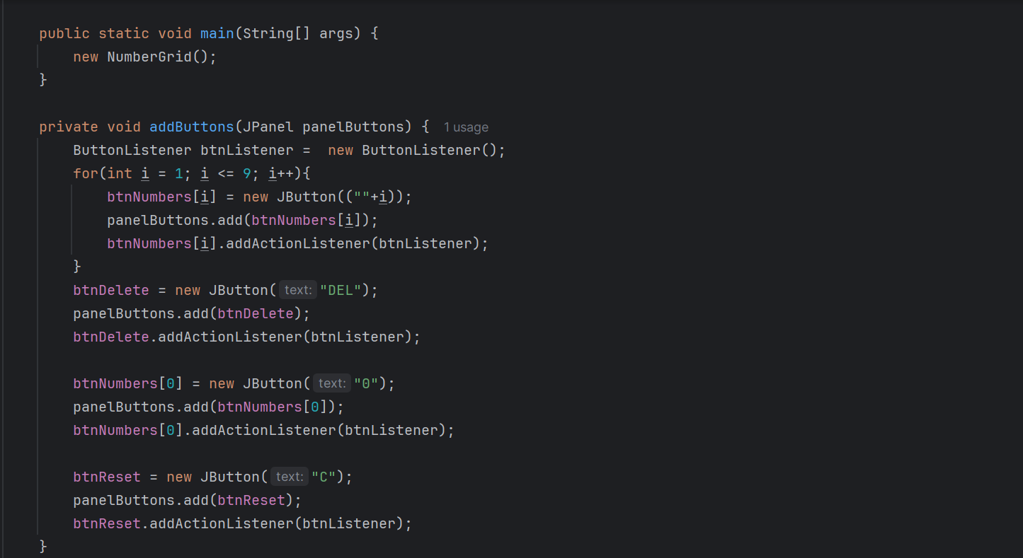 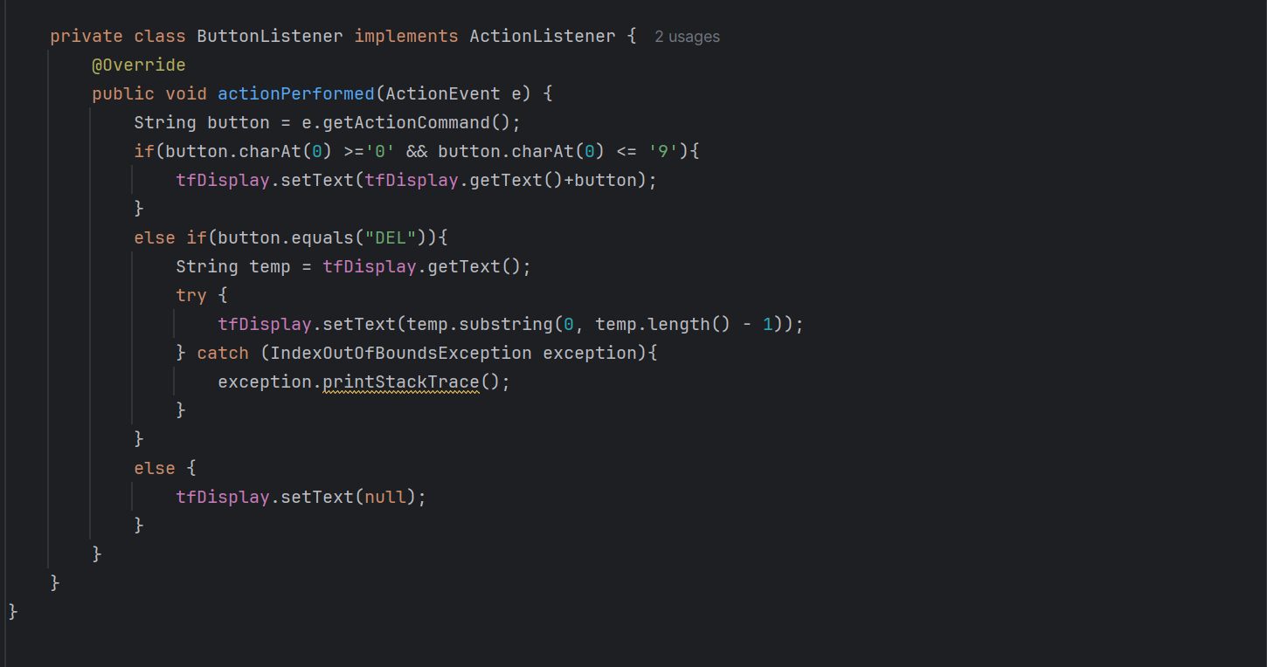

Figure : Source code of NumberGrid

## Demo

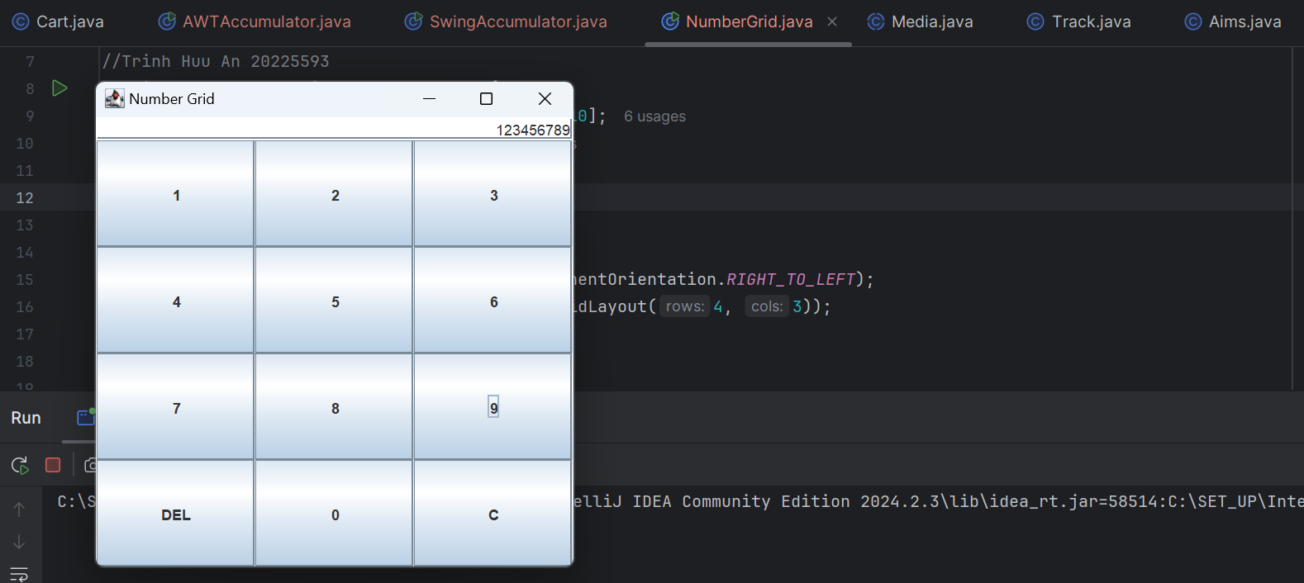

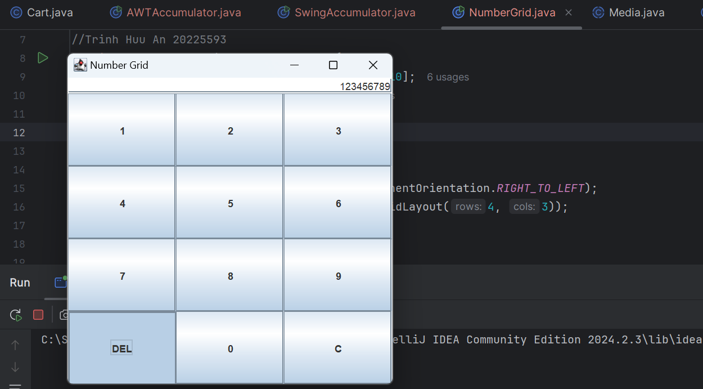

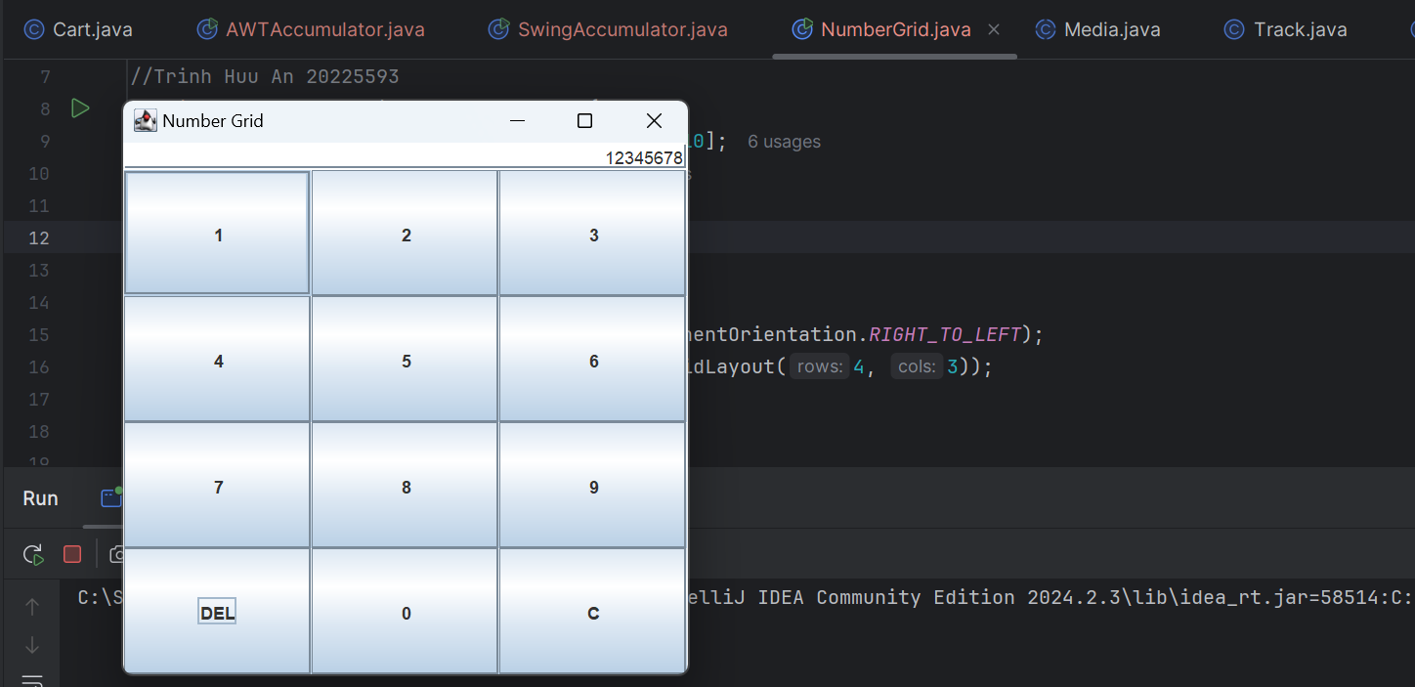

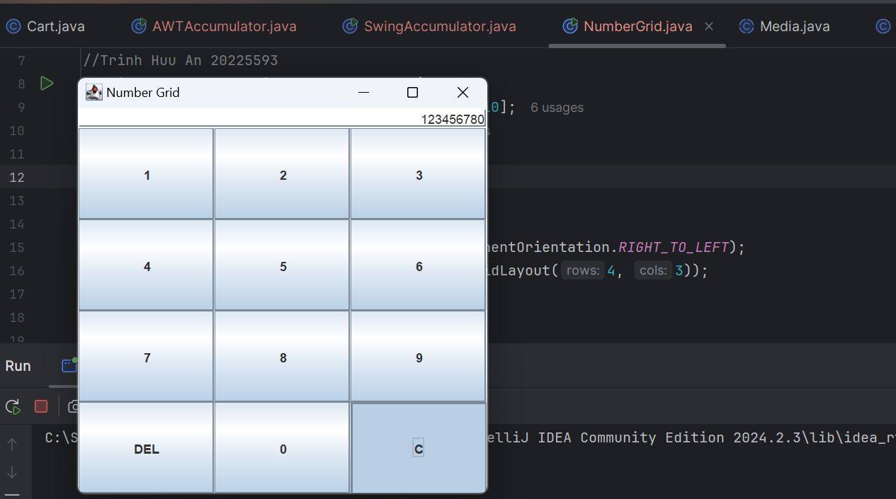 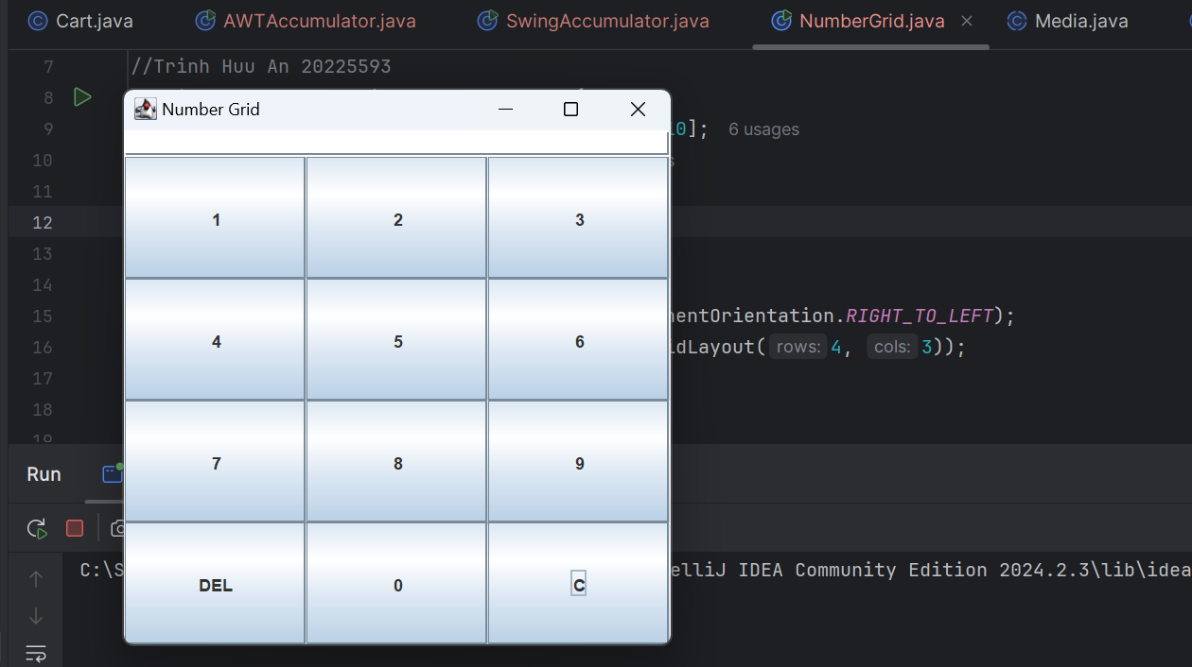

Figure : Demo NumberGrid

# Create a graphical user interface for AIMS with Swing

## Create class StoreScreen

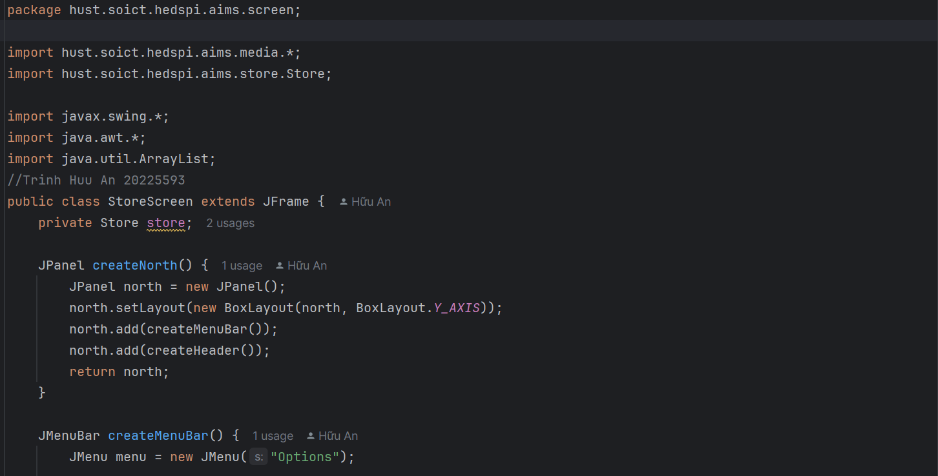

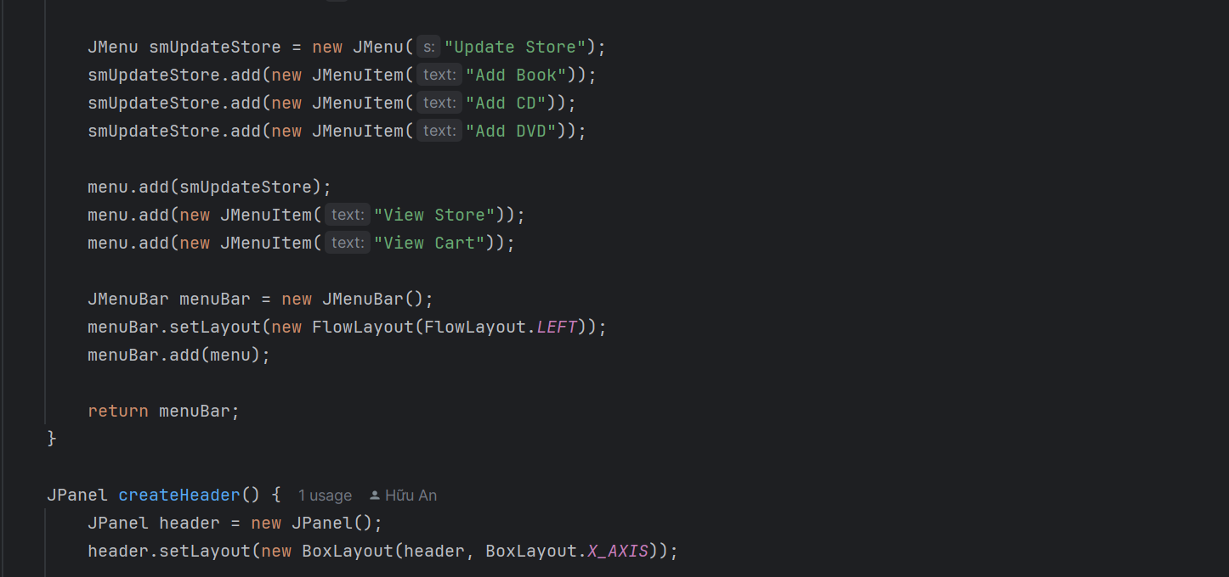

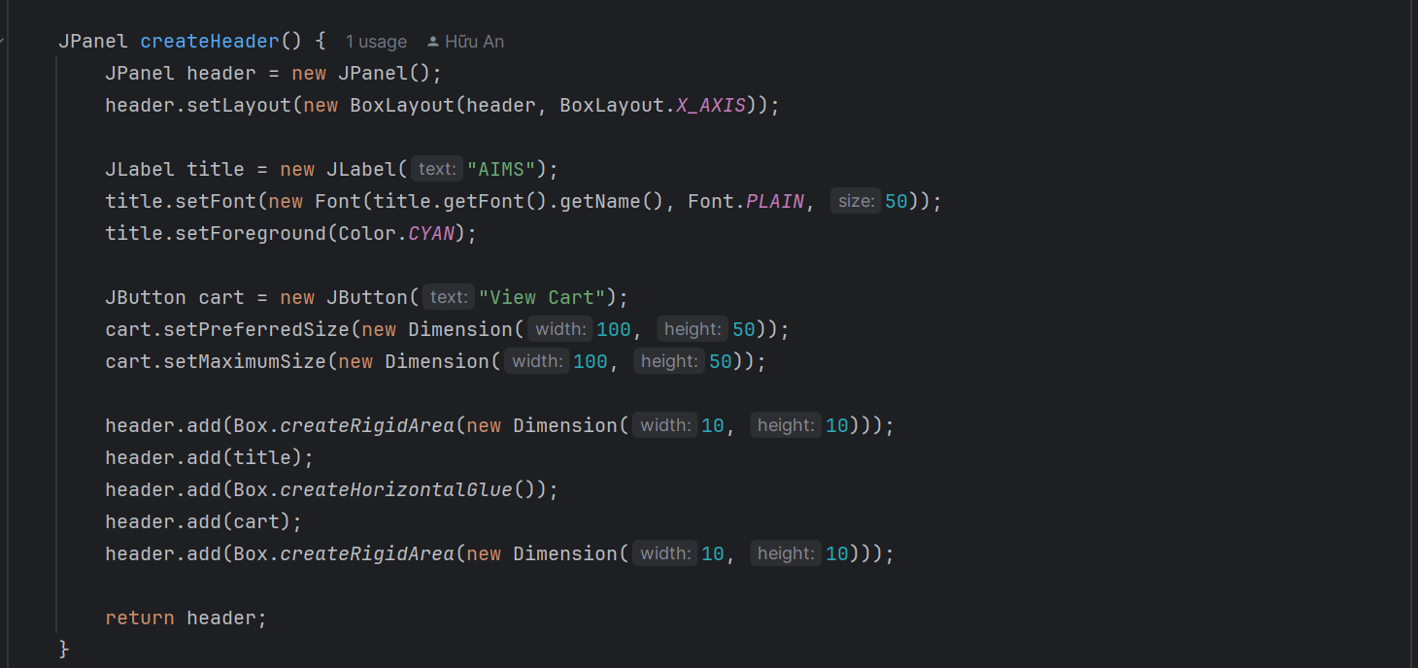

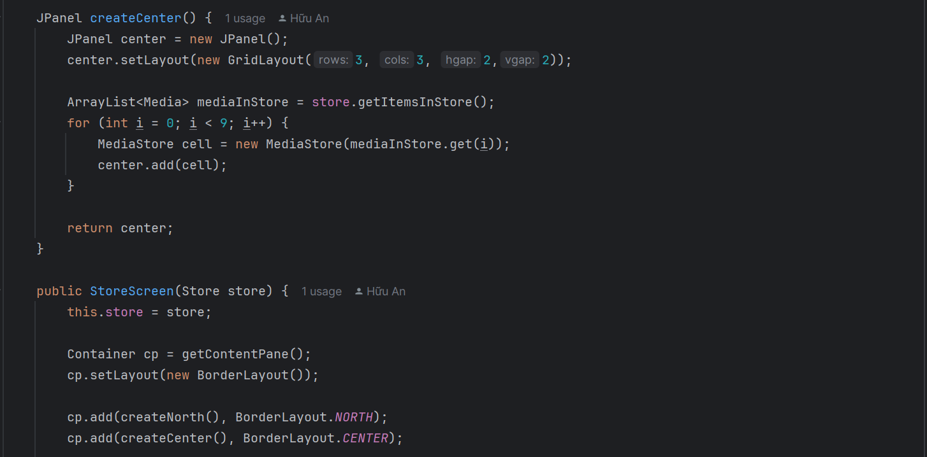

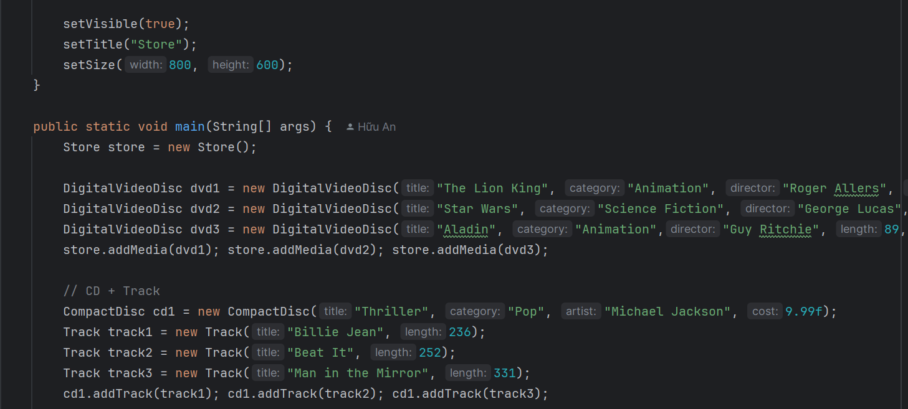

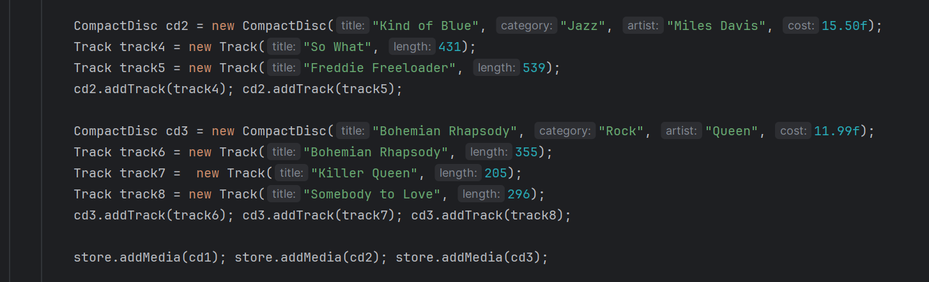

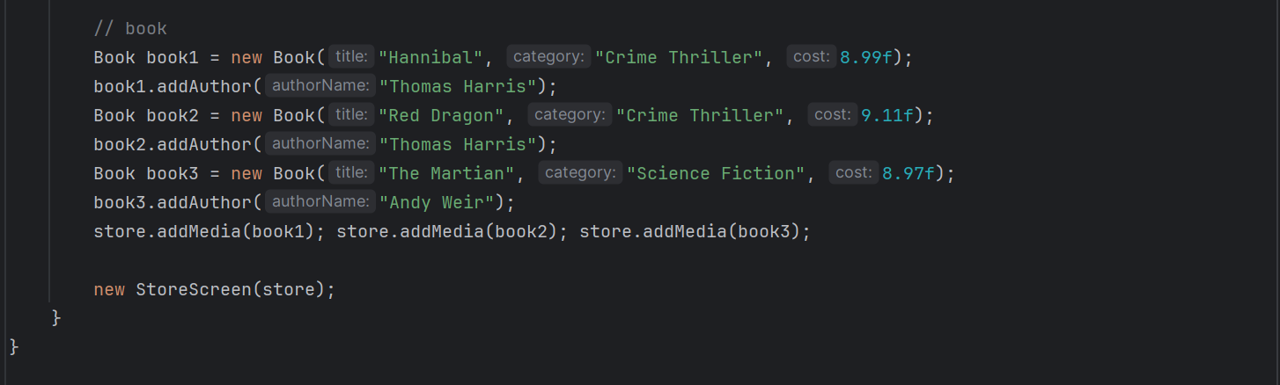

Figure : Class StoreScreen

## Create class MediaStore

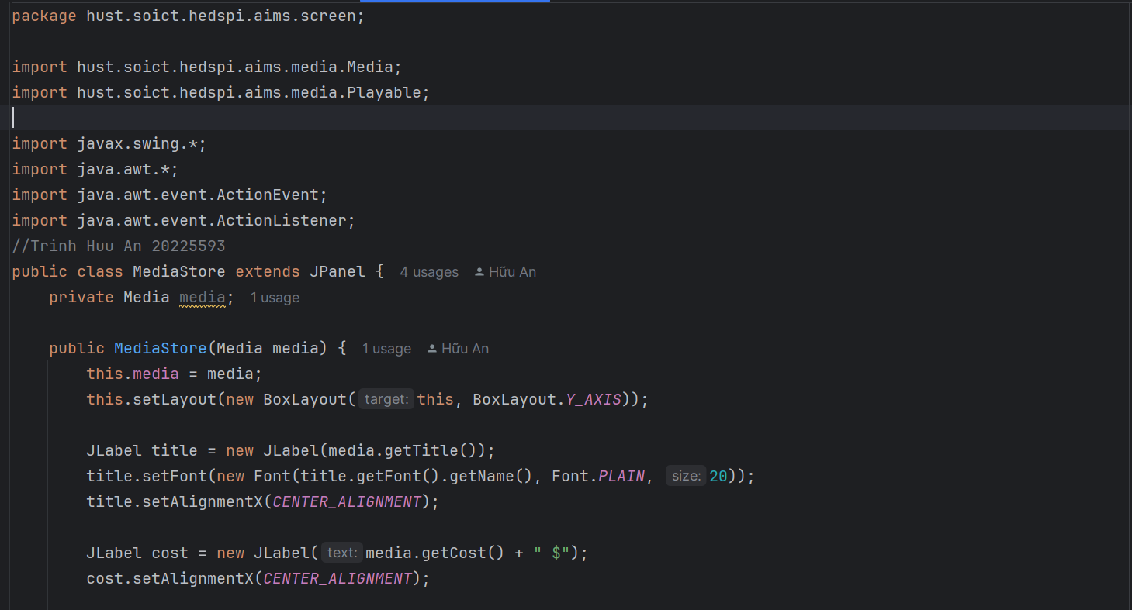

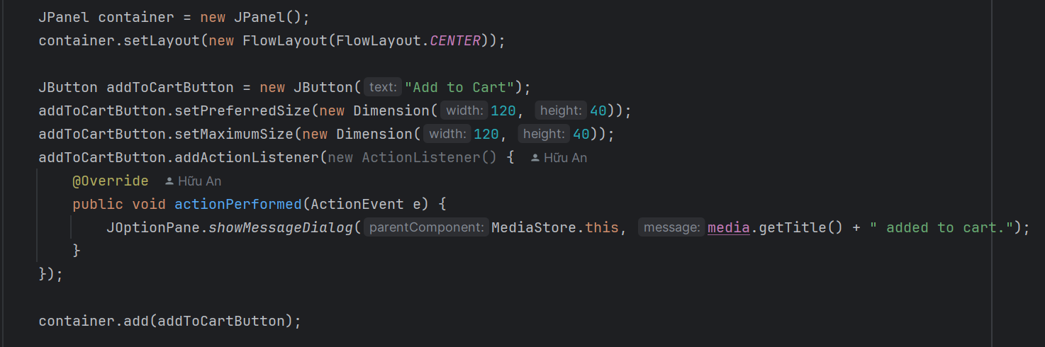

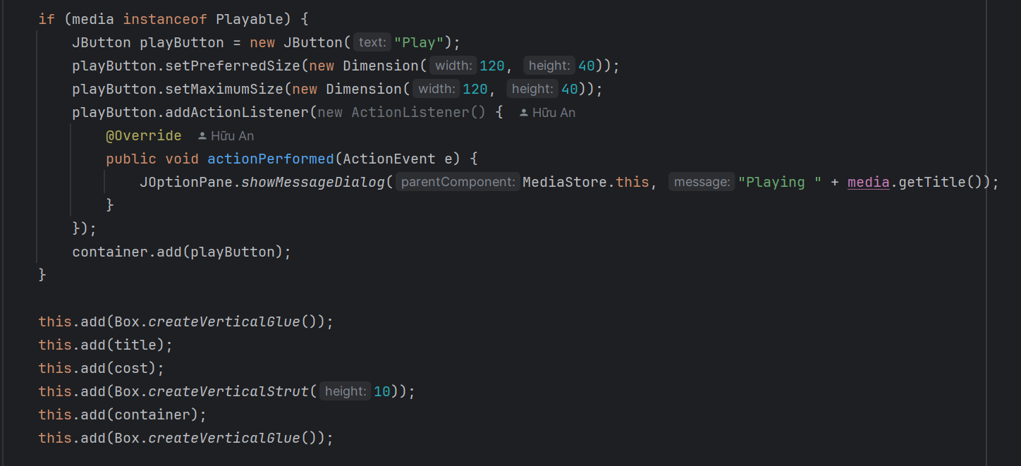

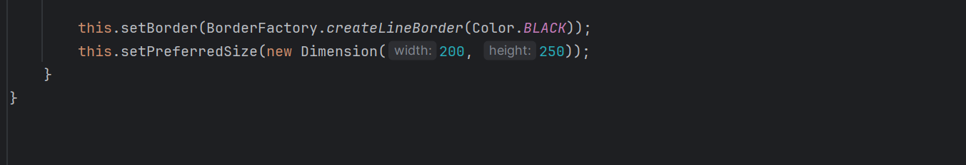

Figure : Class MediaStore

## Demo

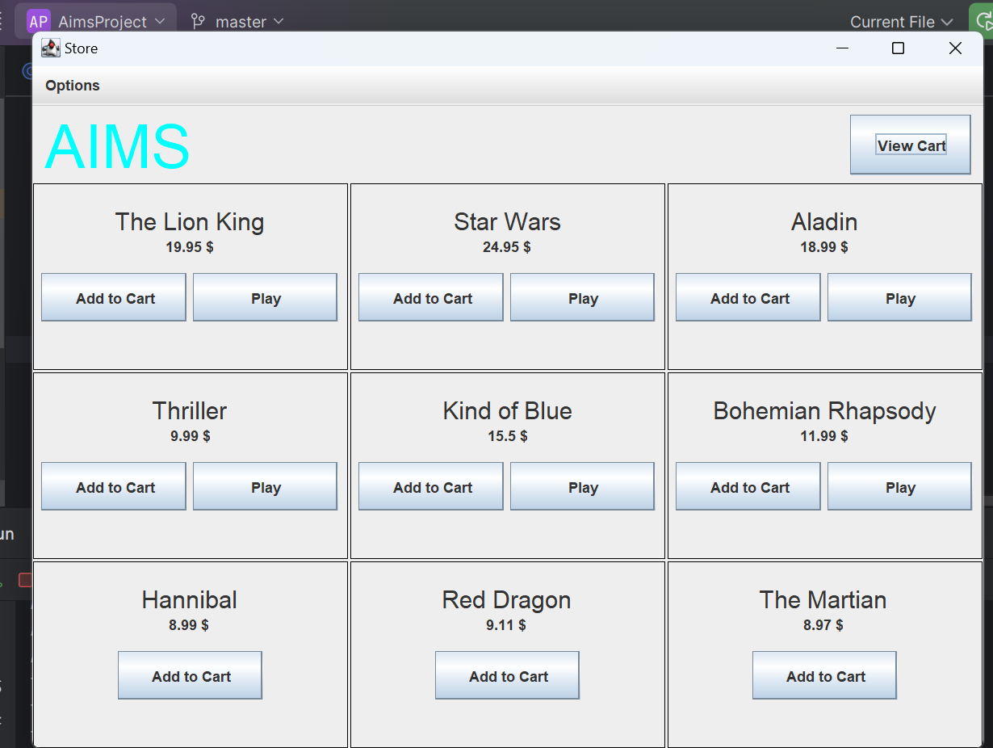

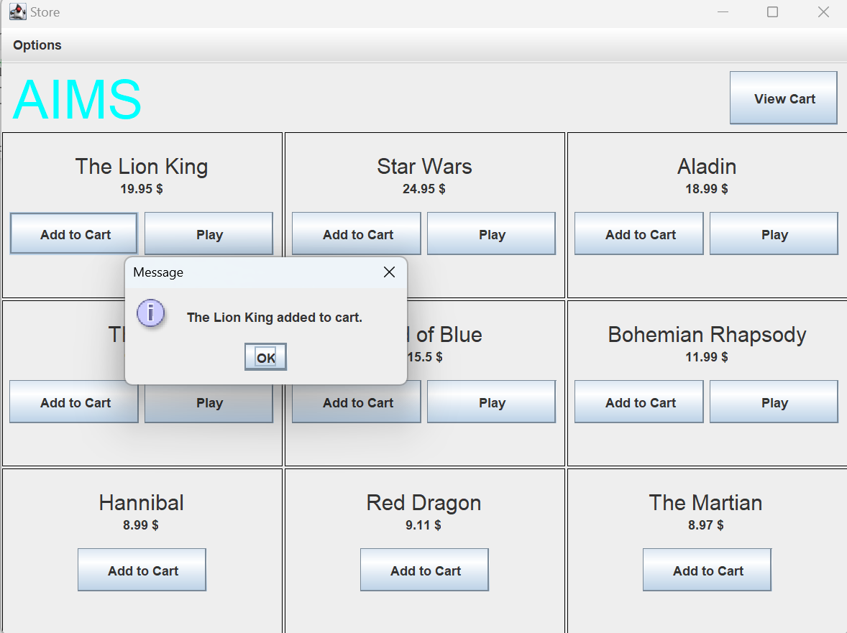

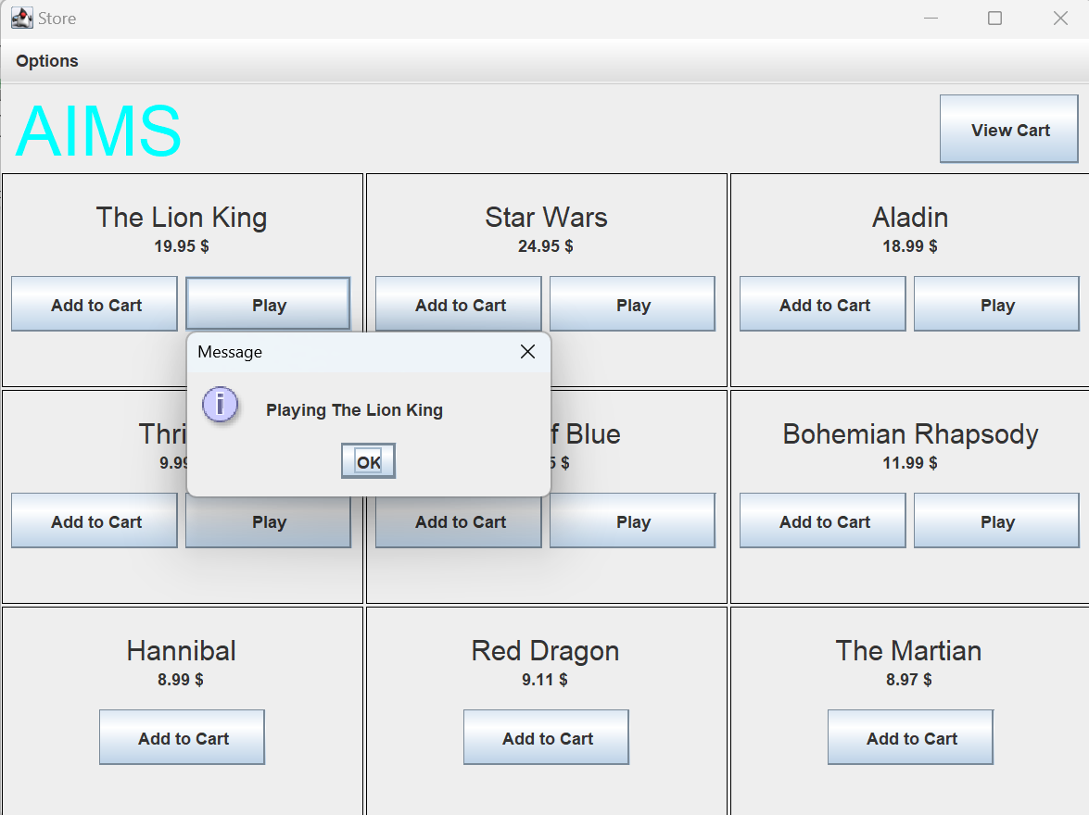

Figure : Demo

# JavaFX API

## Create class Painter

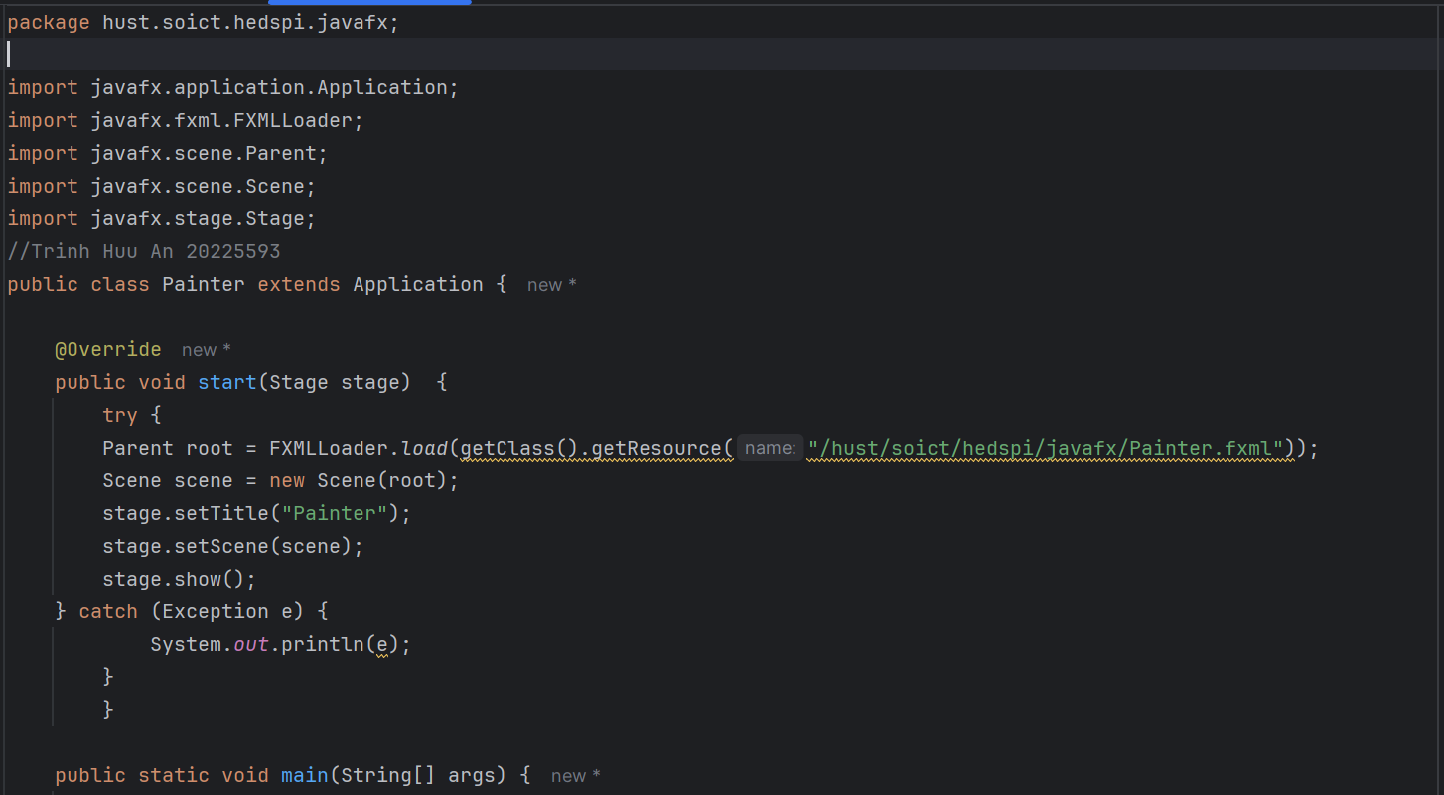

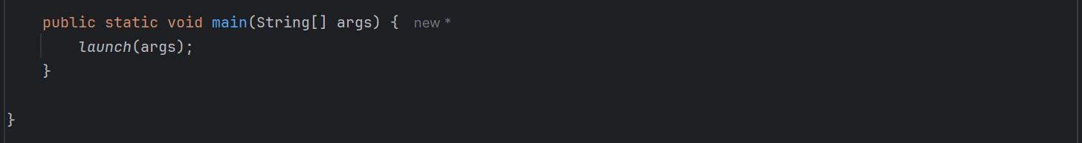

Figure : Class Painter

## Create Painter.fxml

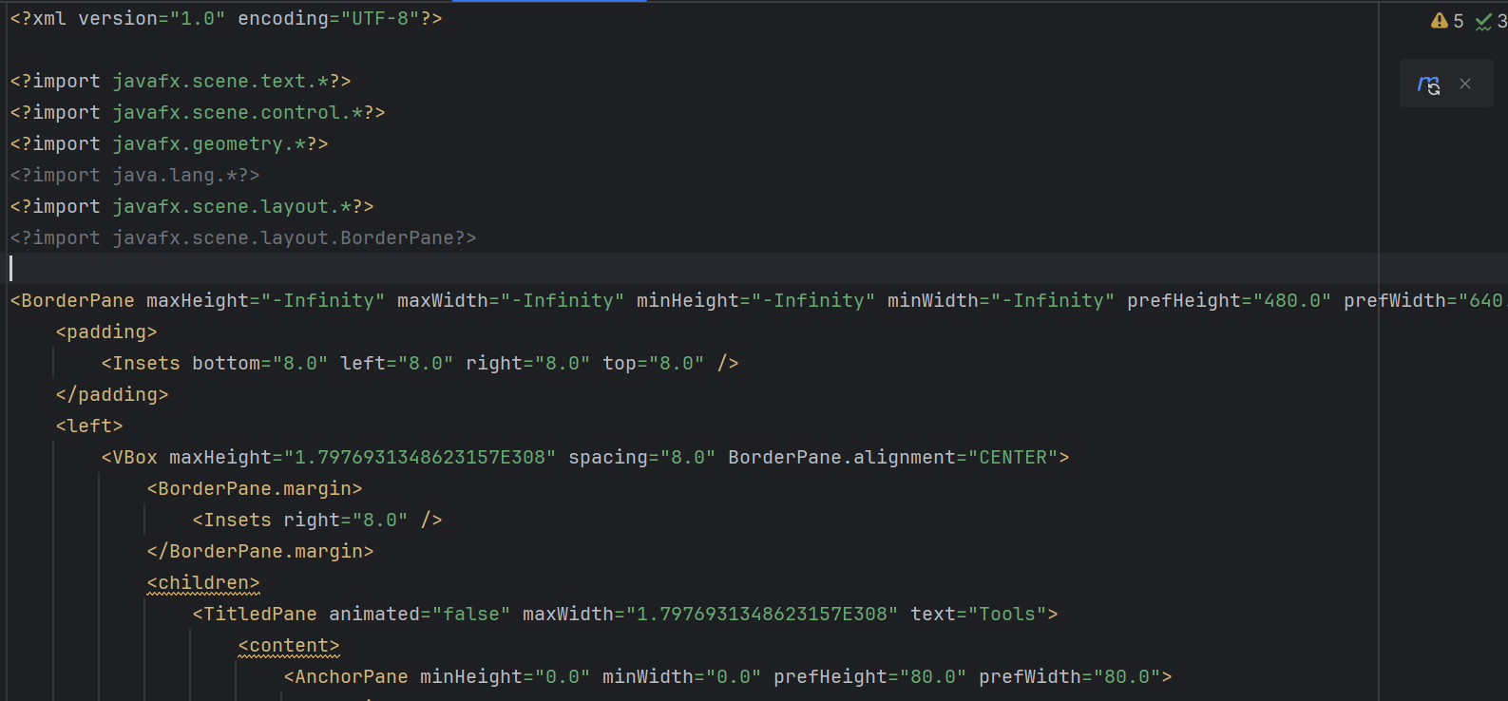





Figure : Painter.fxml

## Create class PainterController



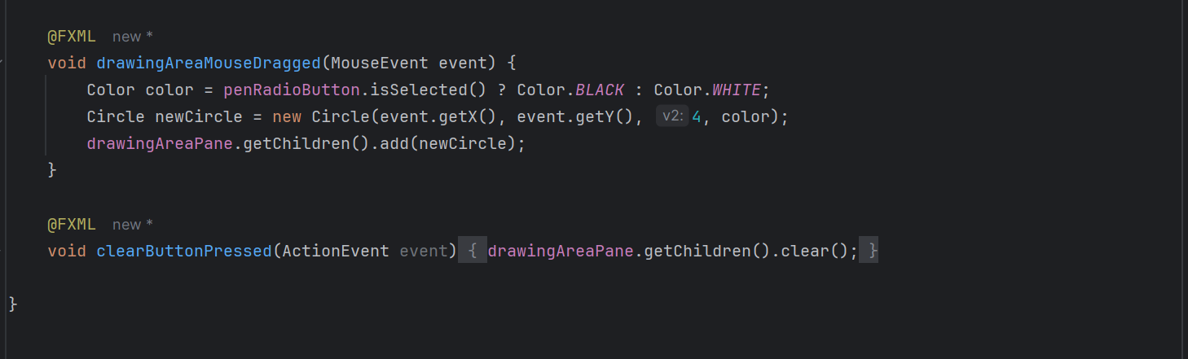

Figure : PainterController

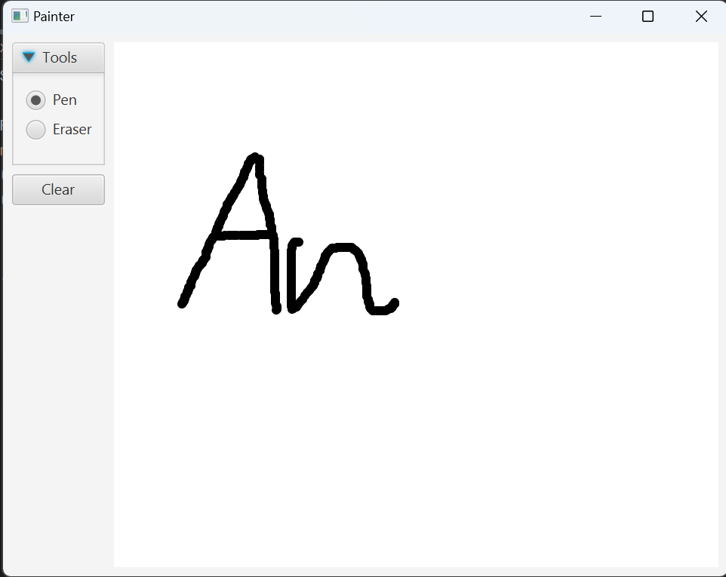

Figure : Use pen

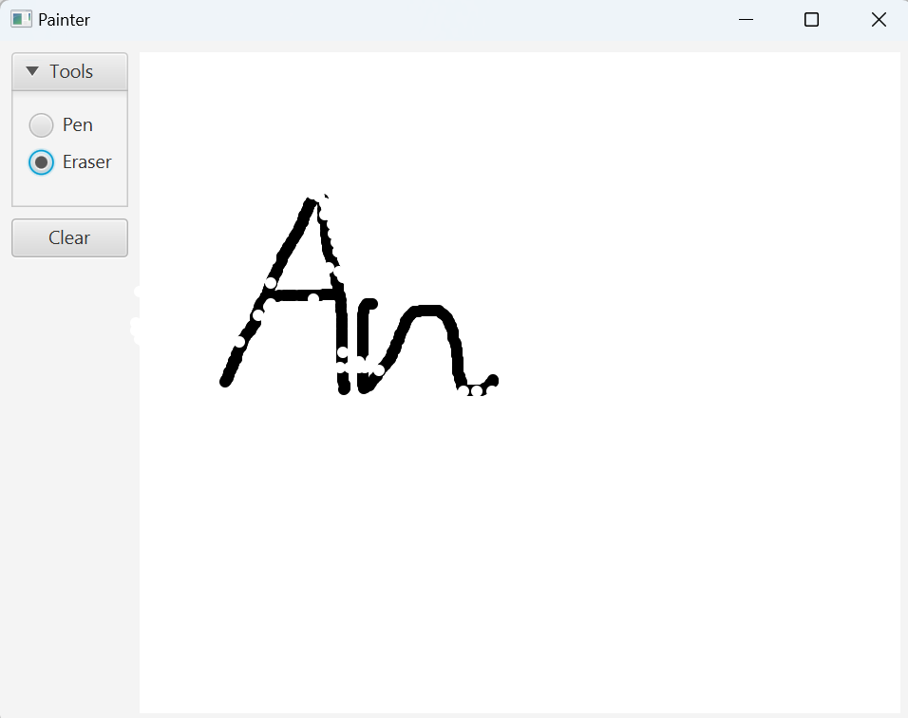

Figure : Use eraser

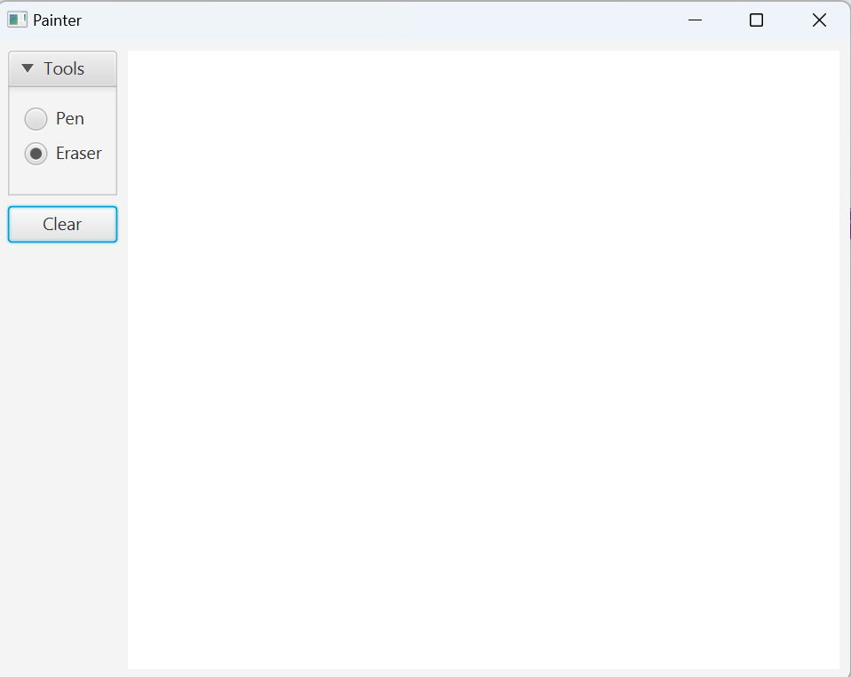

Figure : Clear Button

# View Cart Screen

## Create cart.fxml

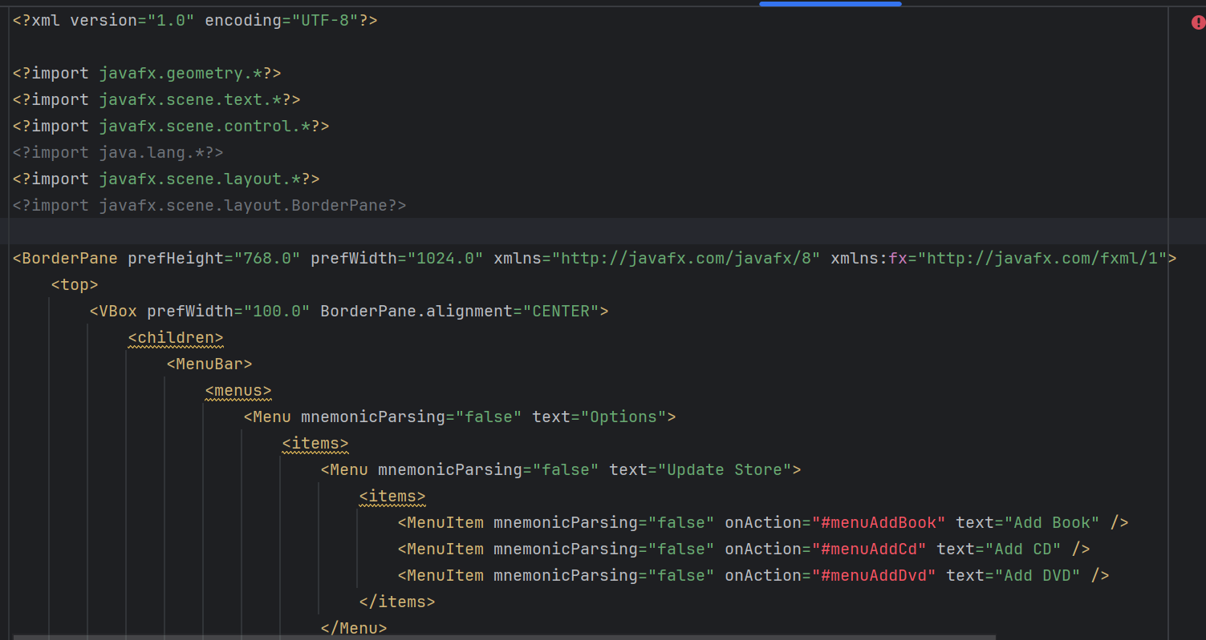

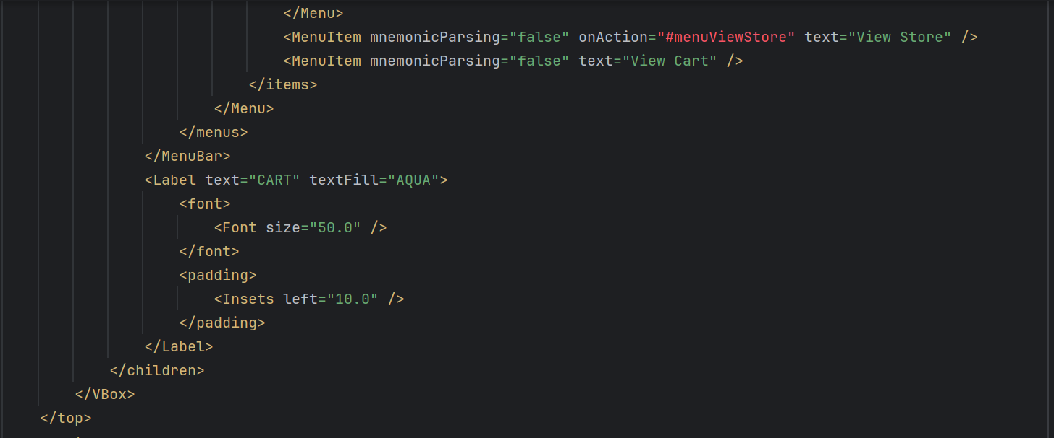

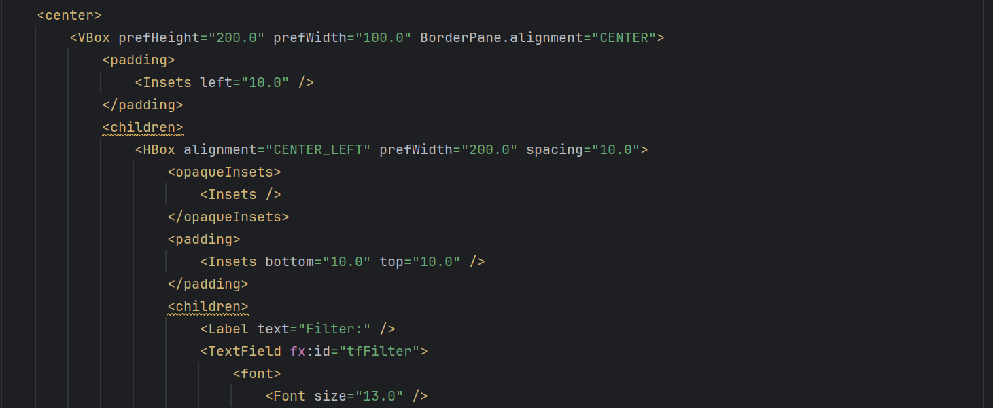

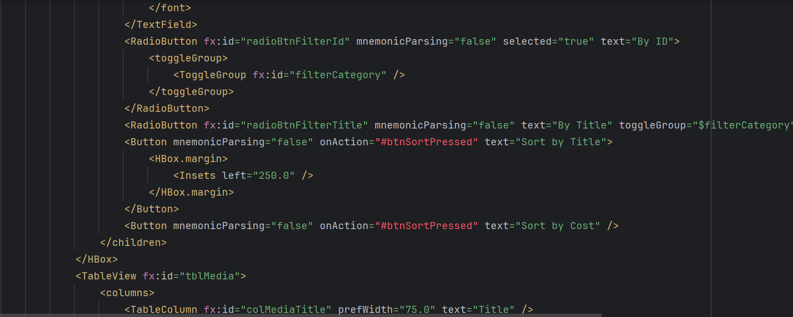

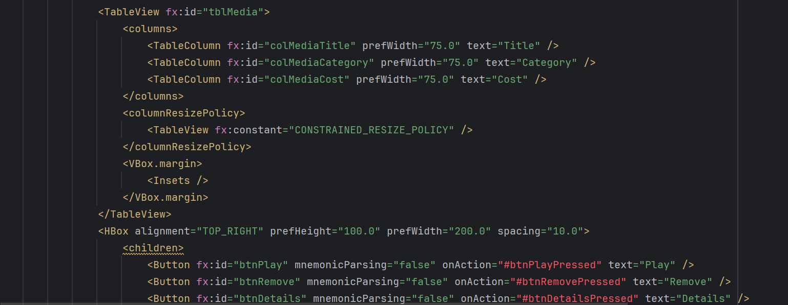

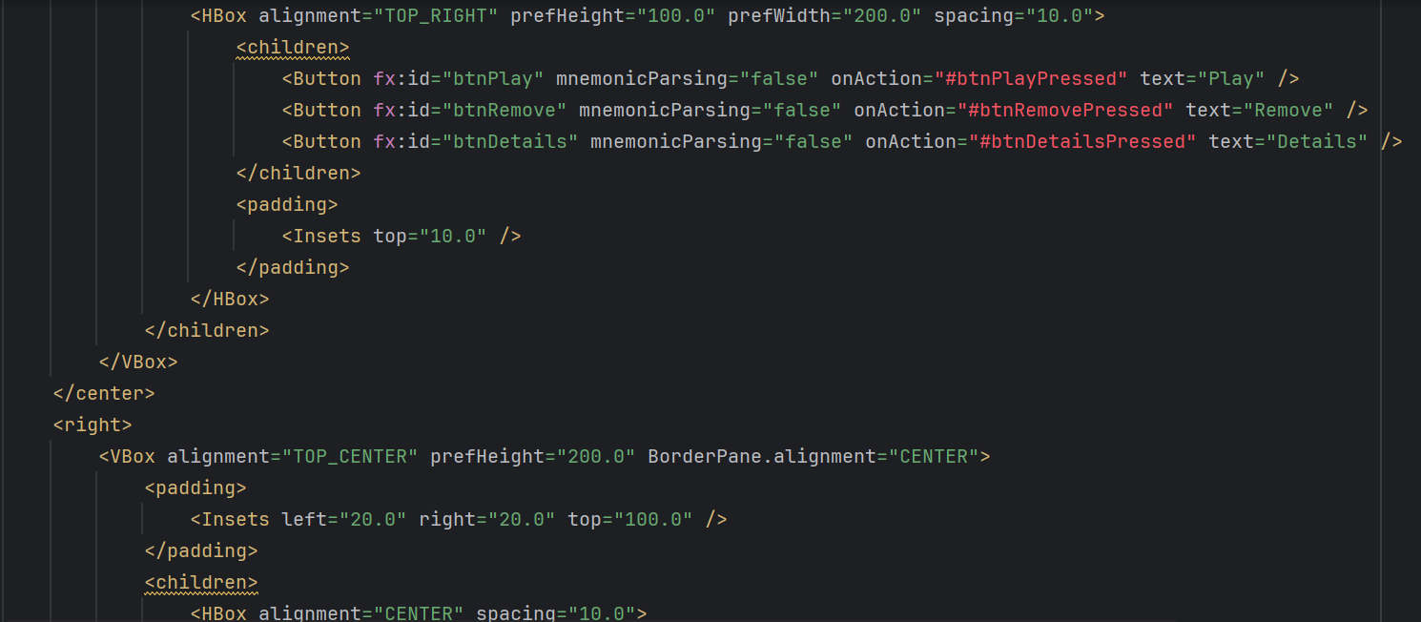

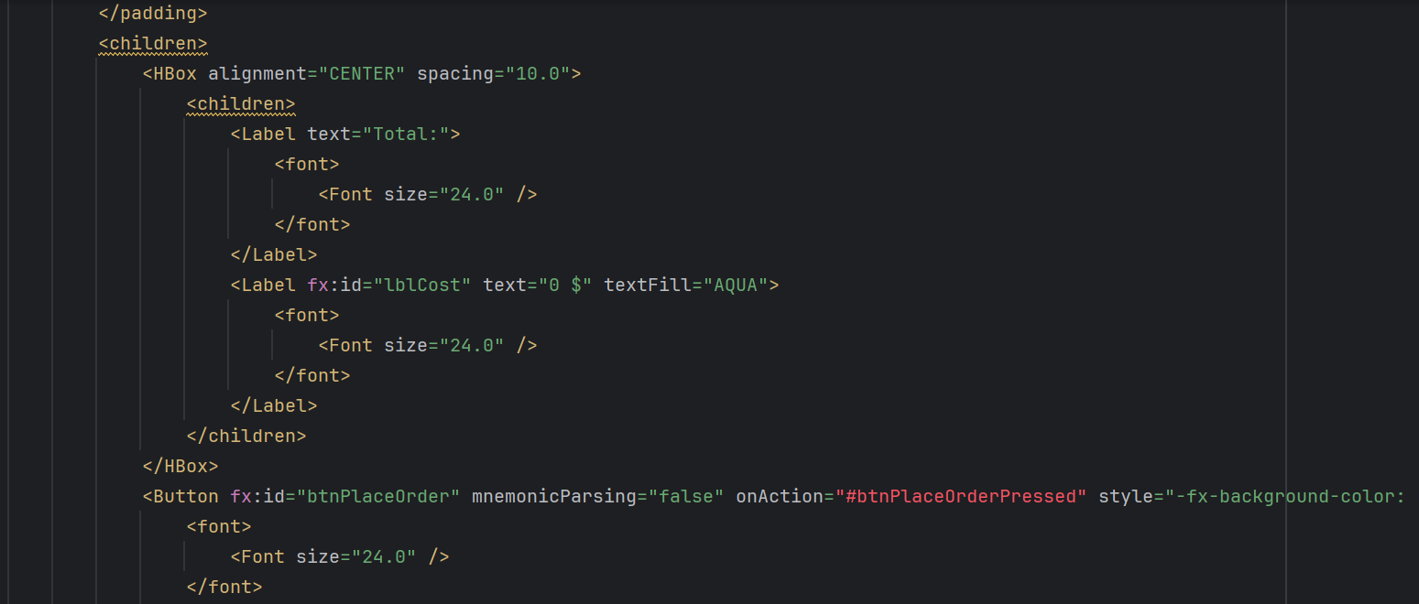

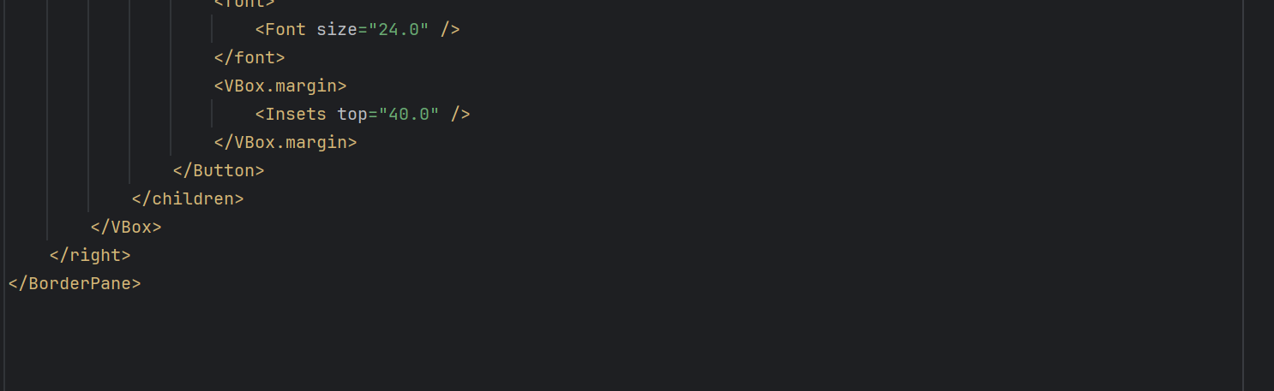

Figure : cart.fxml

## Create class CartScreen

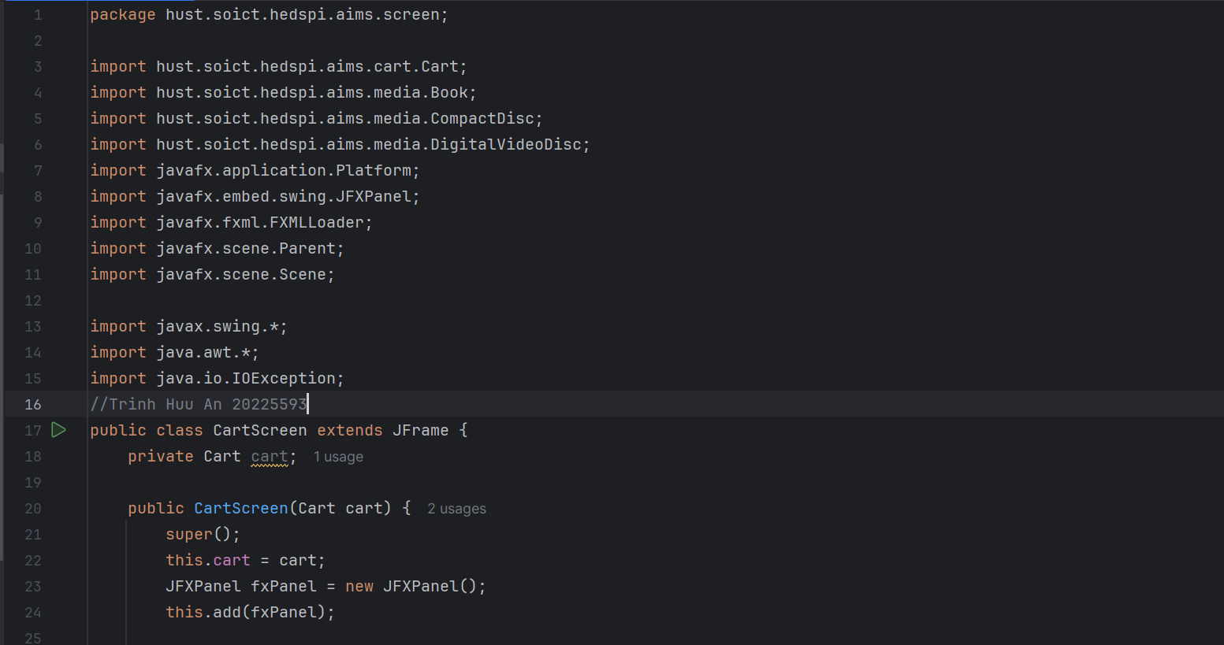

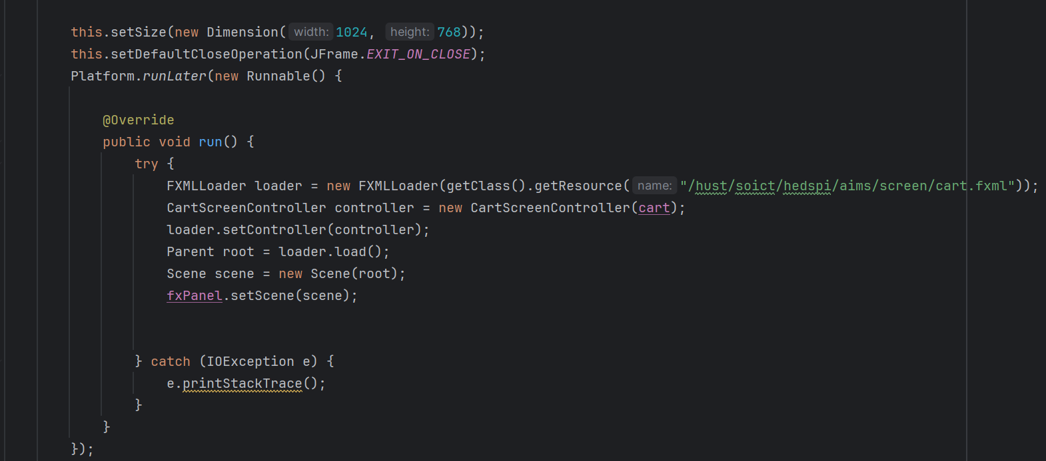

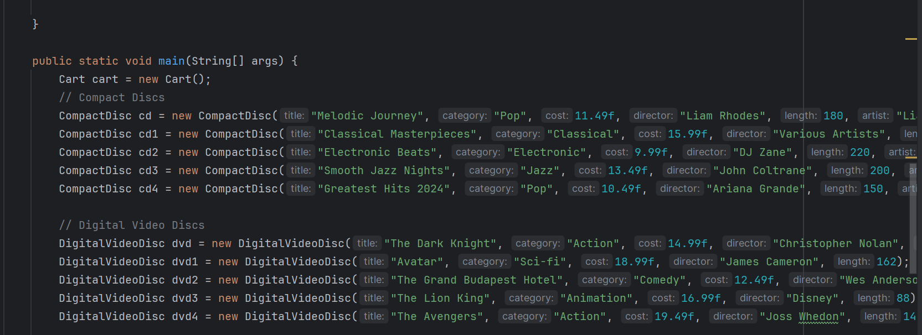

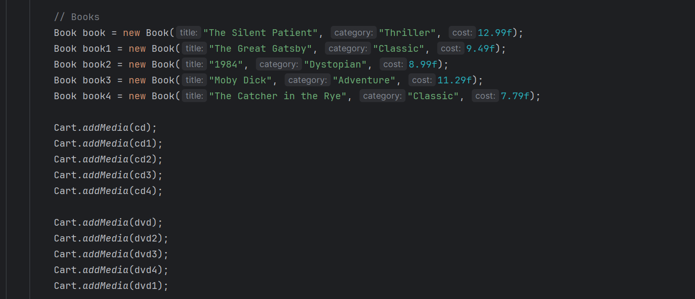

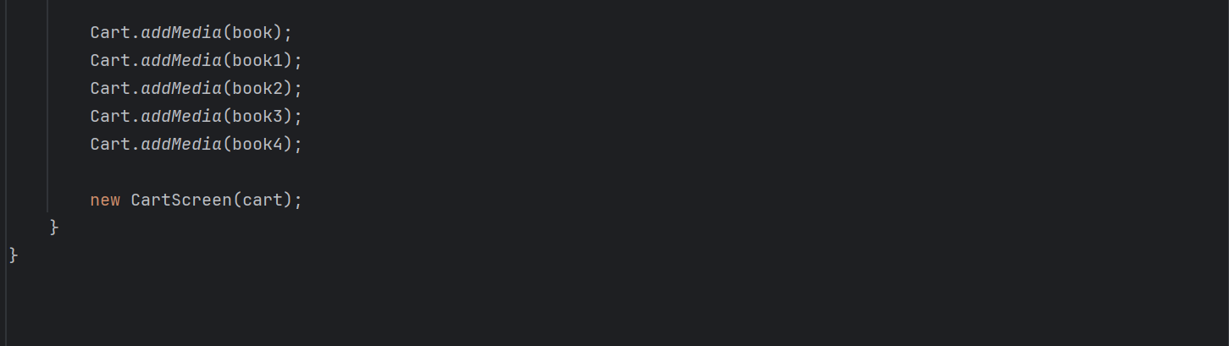

Figure : Create CartScreen

## Create class CartScreenController

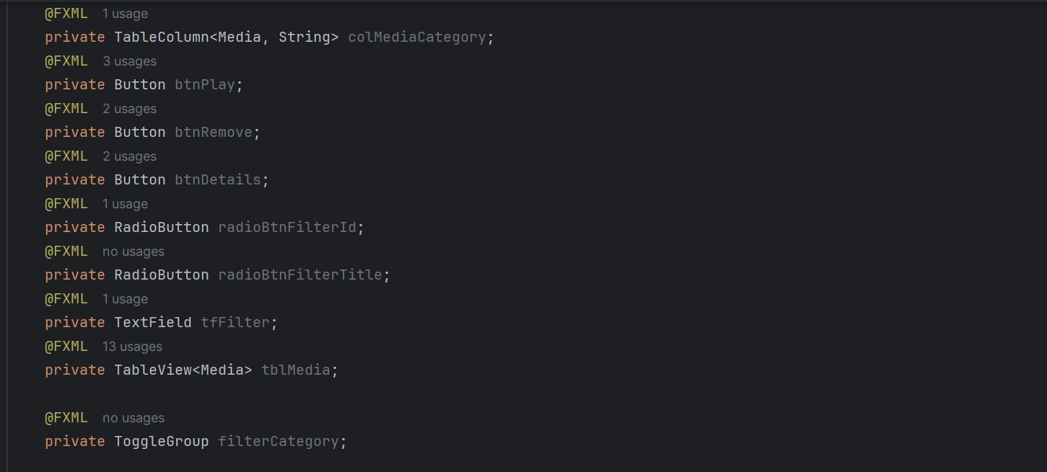

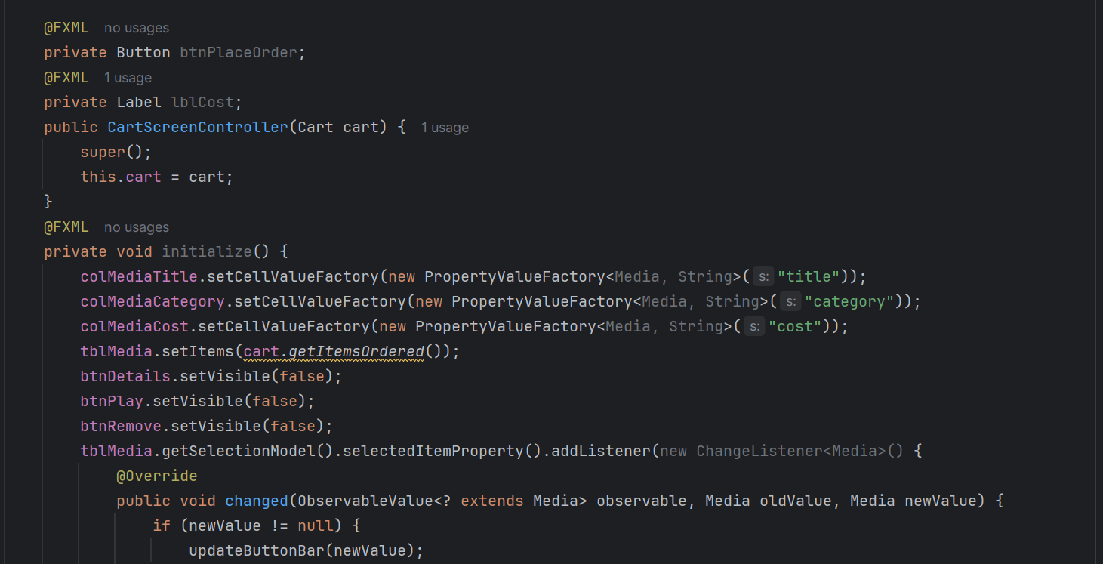

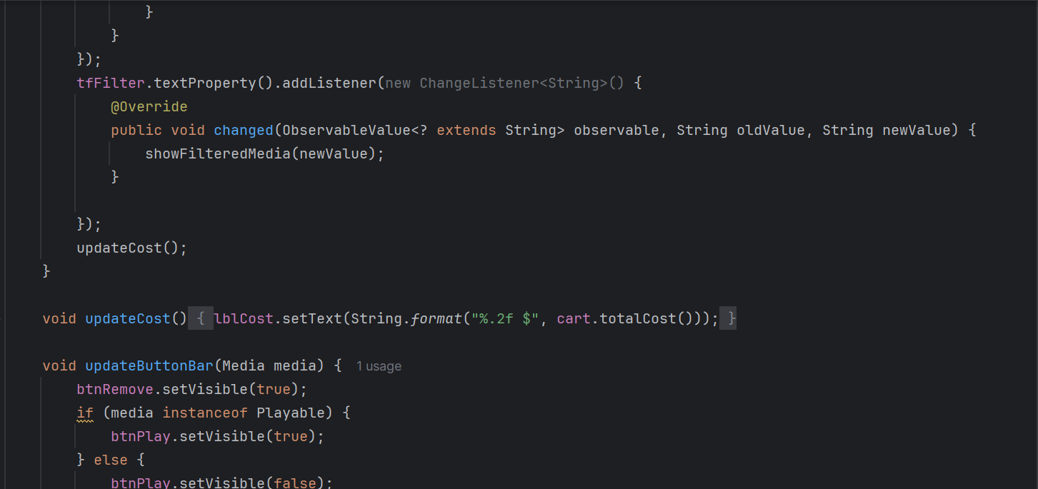

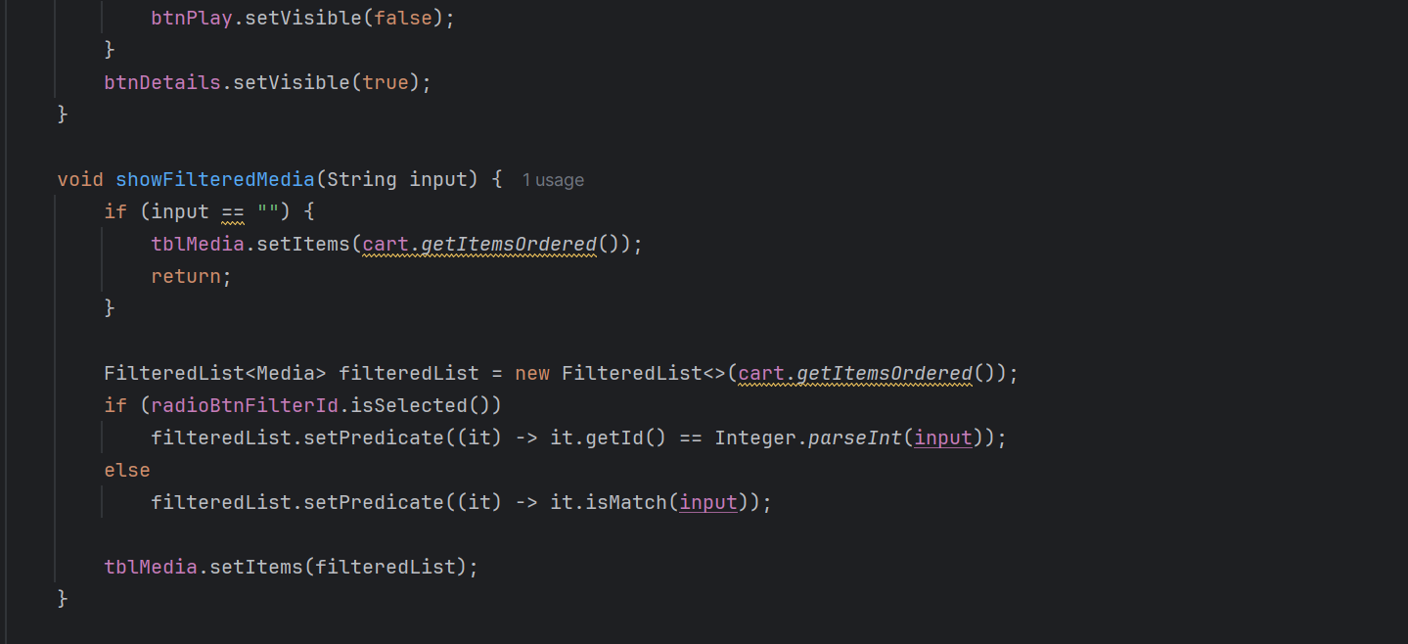

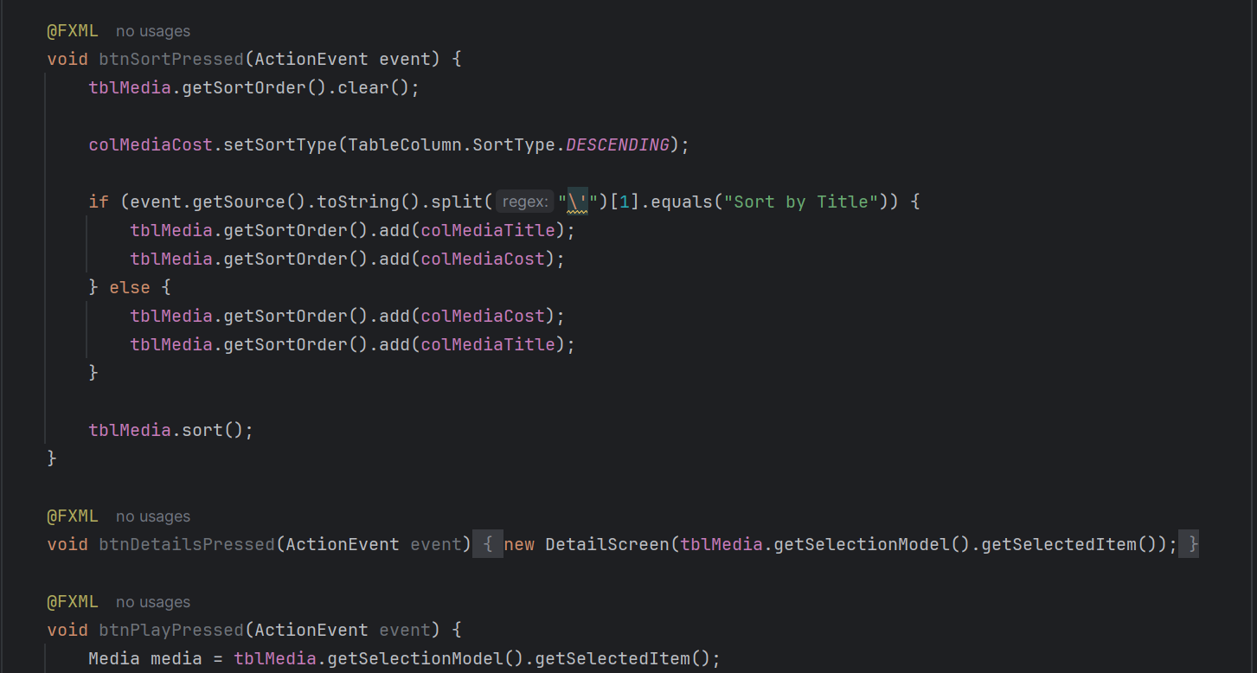

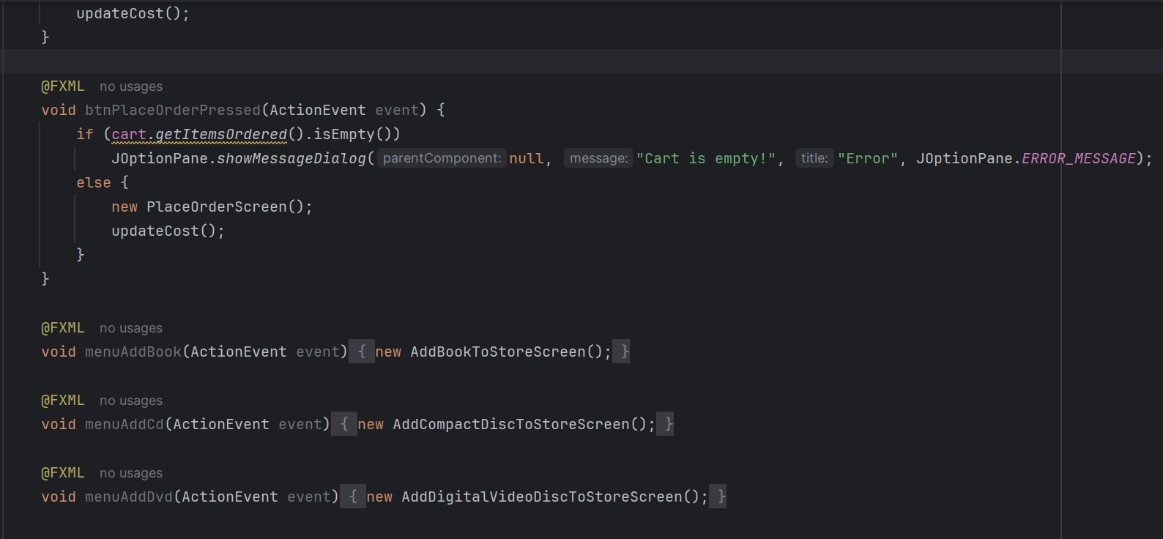

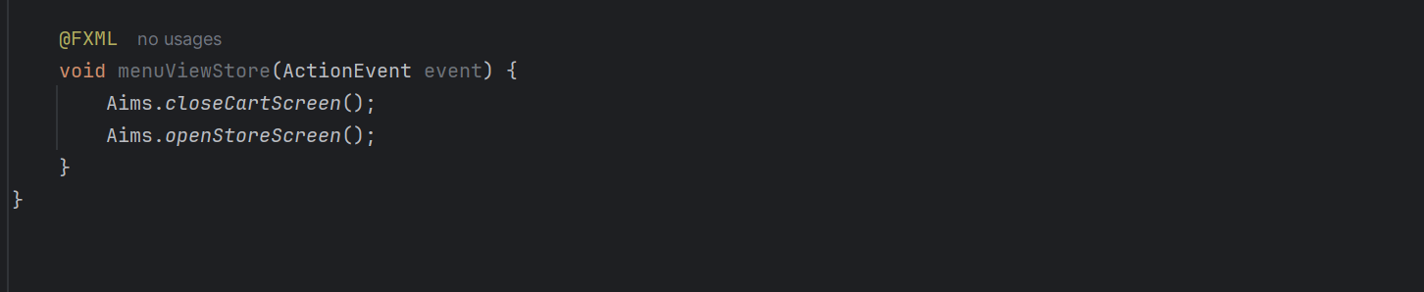

Figure : Create CartScreenController

## Demo

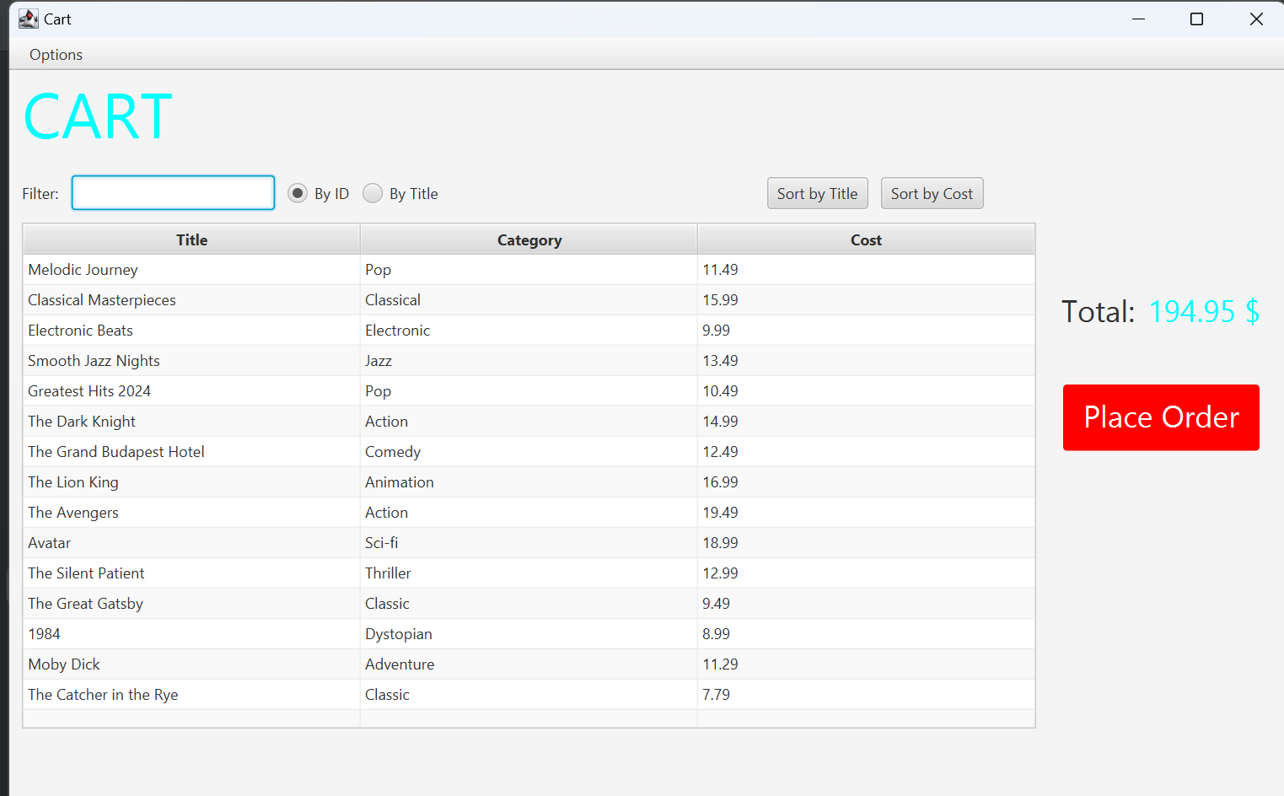

Figure : Demo

1. Updating buttons based on selected item in TableView –

ChangeListener

## Edit class CartScreenController

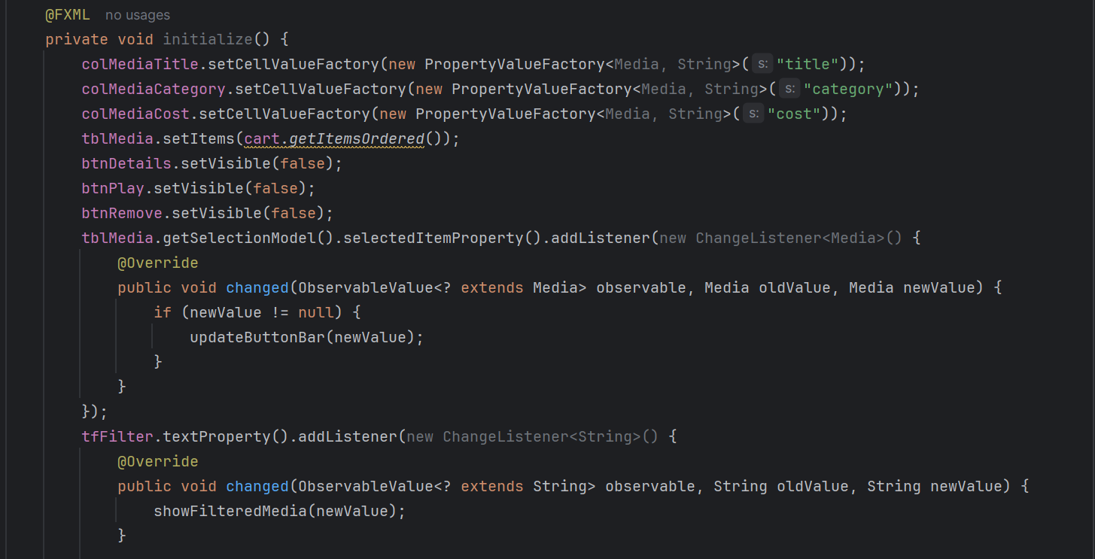

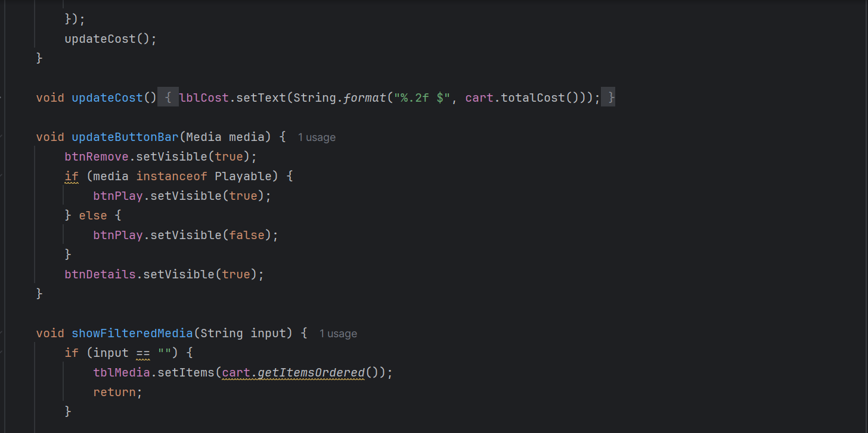

Figure : Edit class CartScreenController

## Demo

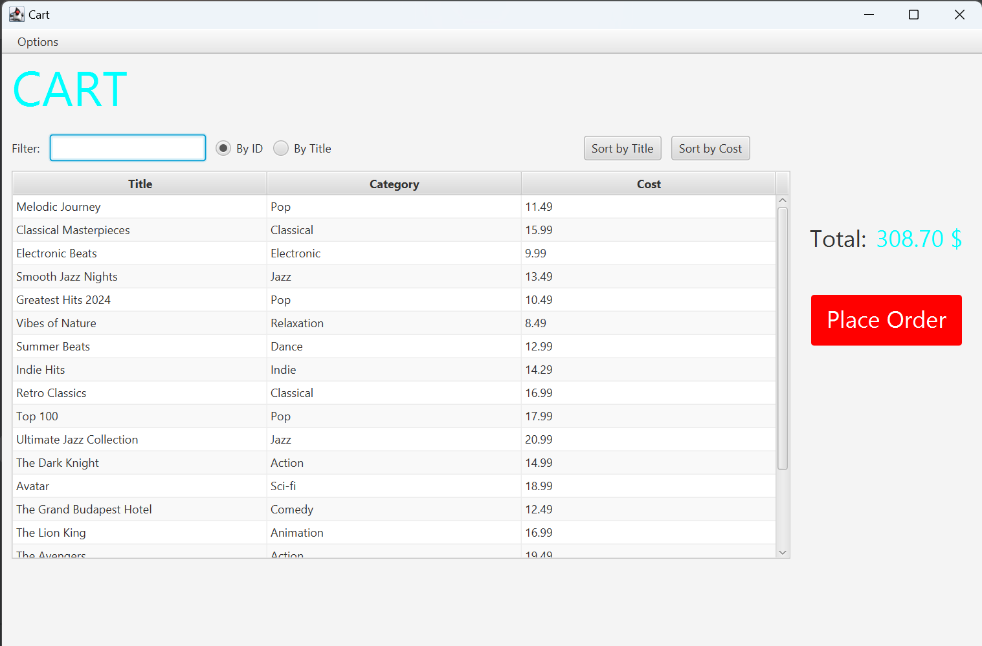

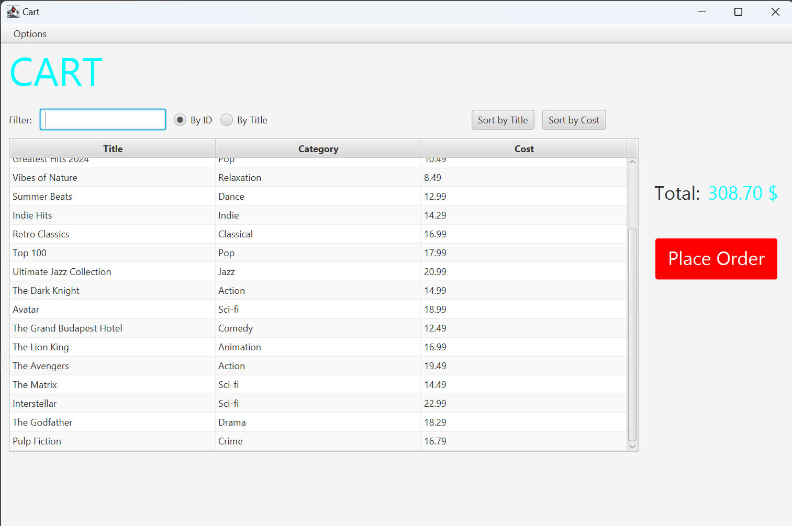

Figure : Demo

# Deleting a media

## Code

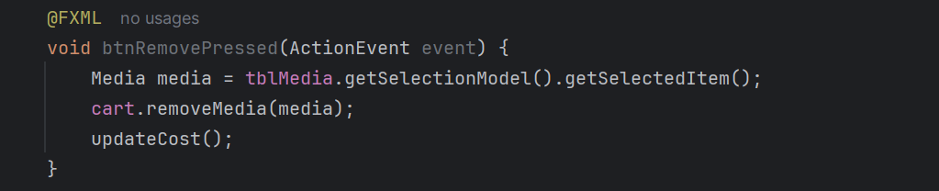

Figure : btnRemovePressed method

## Demo

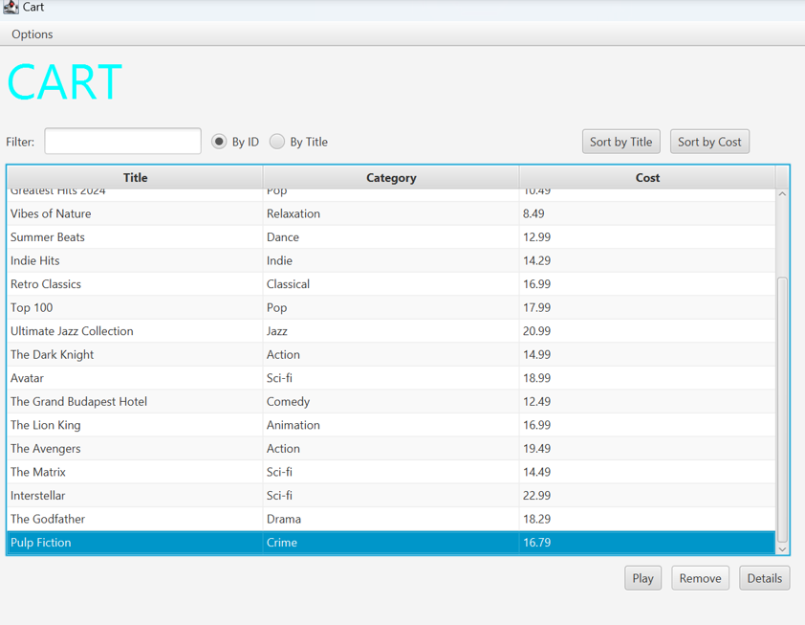

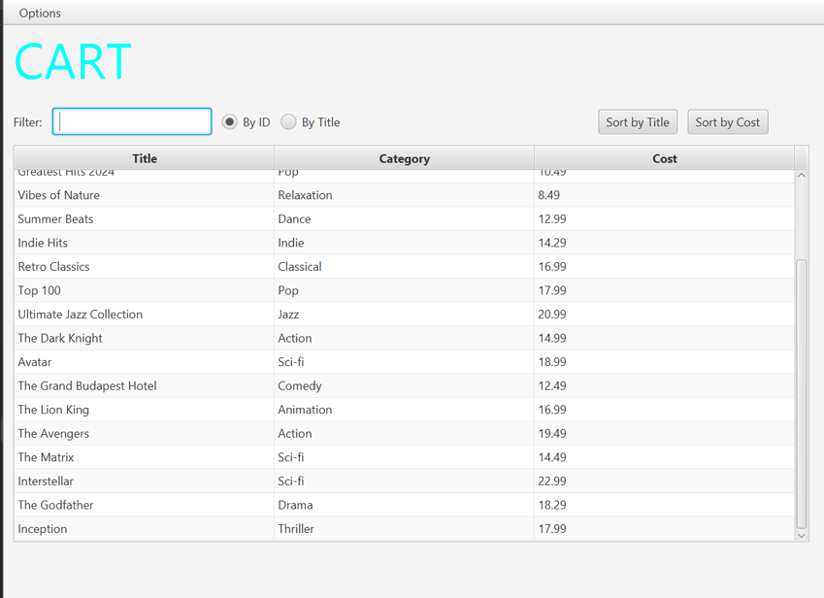Figure : Demo

# Complete the Aims GUI application

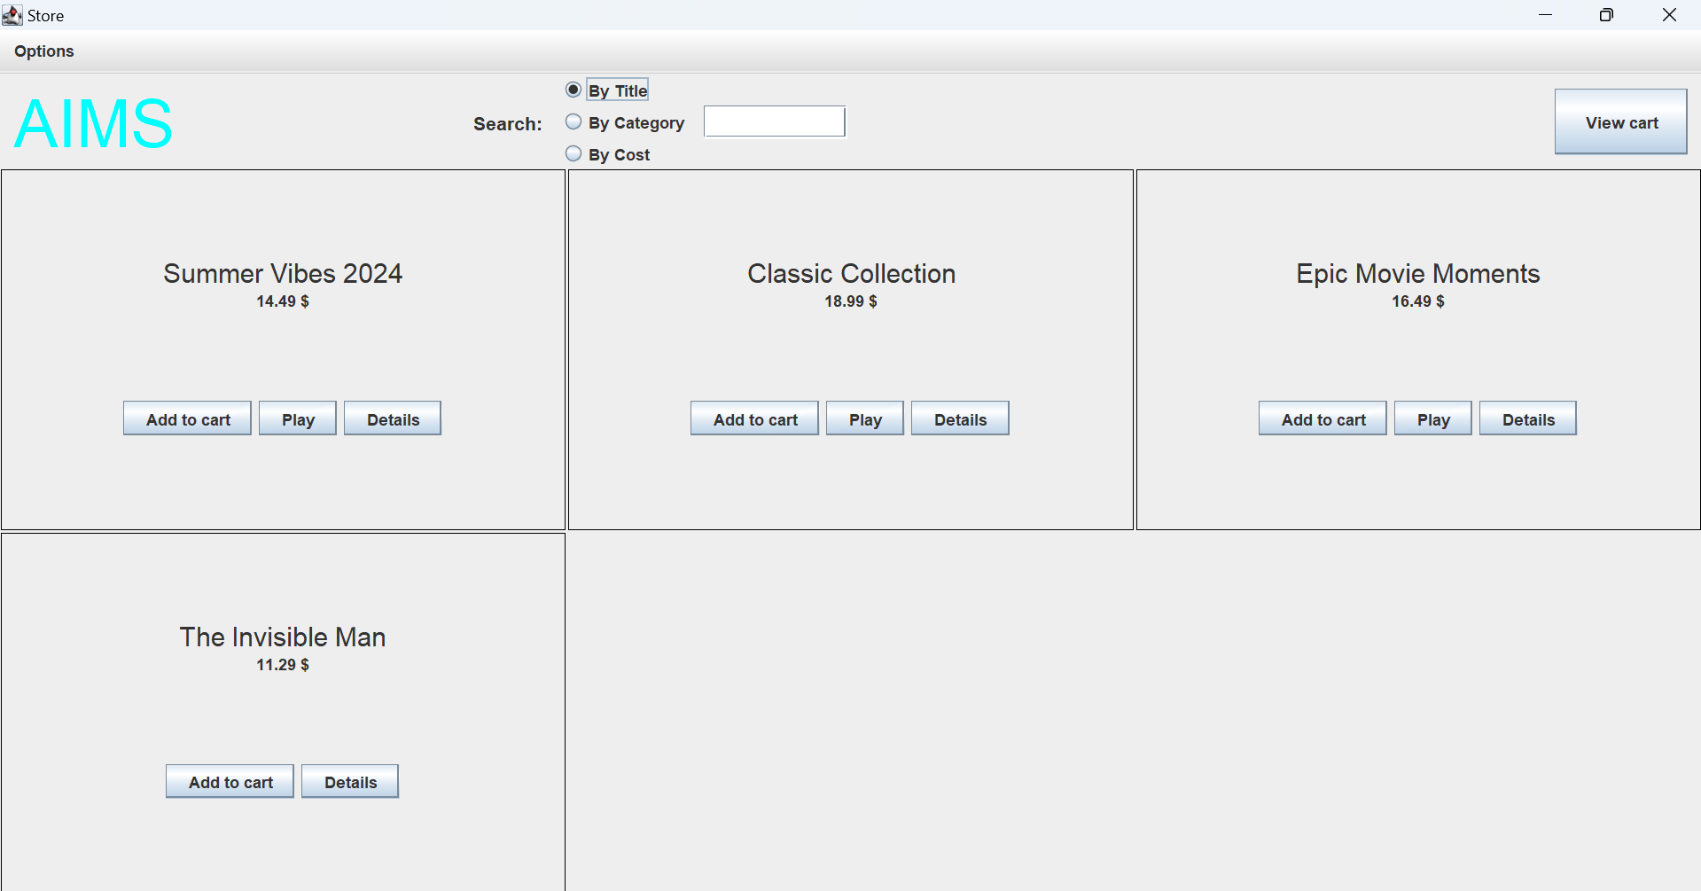

Figure : Store before add book

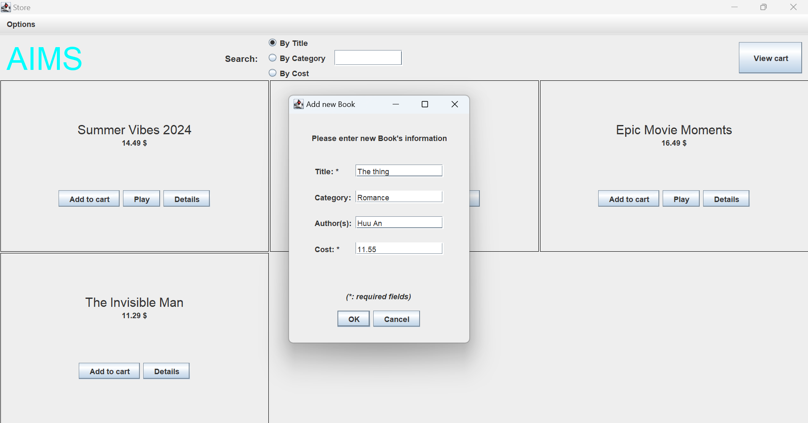

Figure : Add book

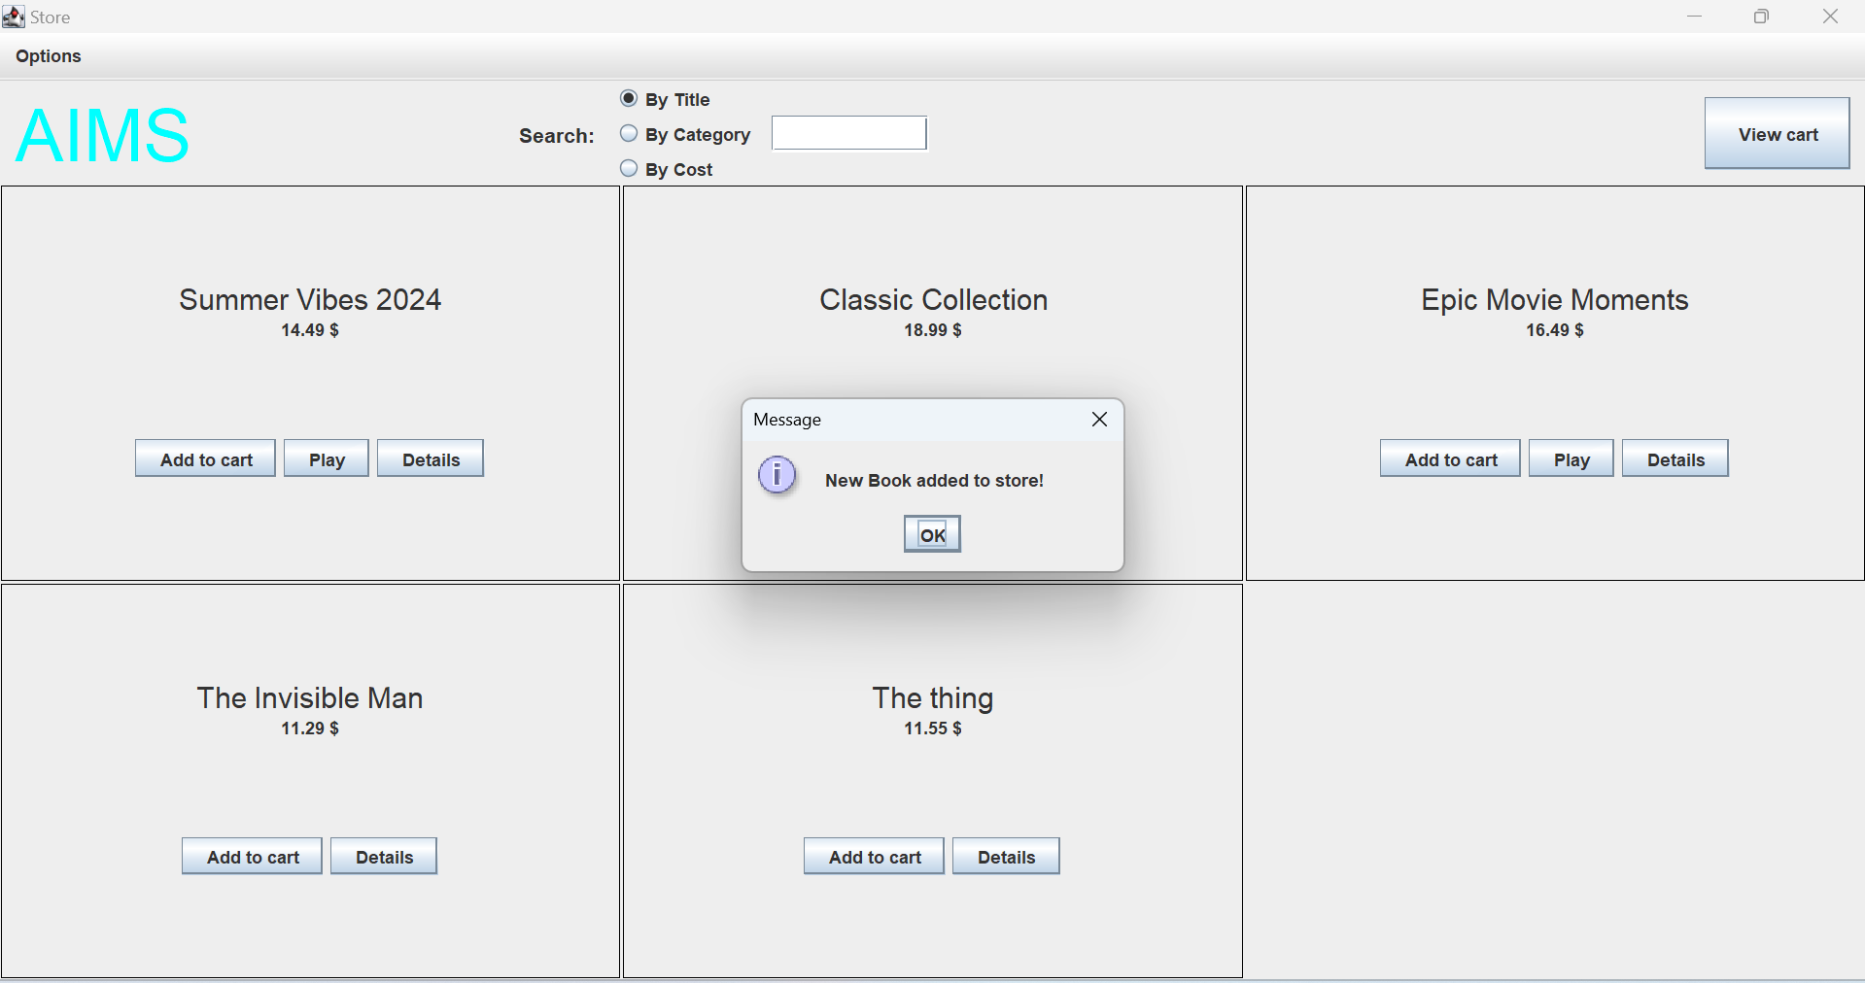

Figure : Store after add book

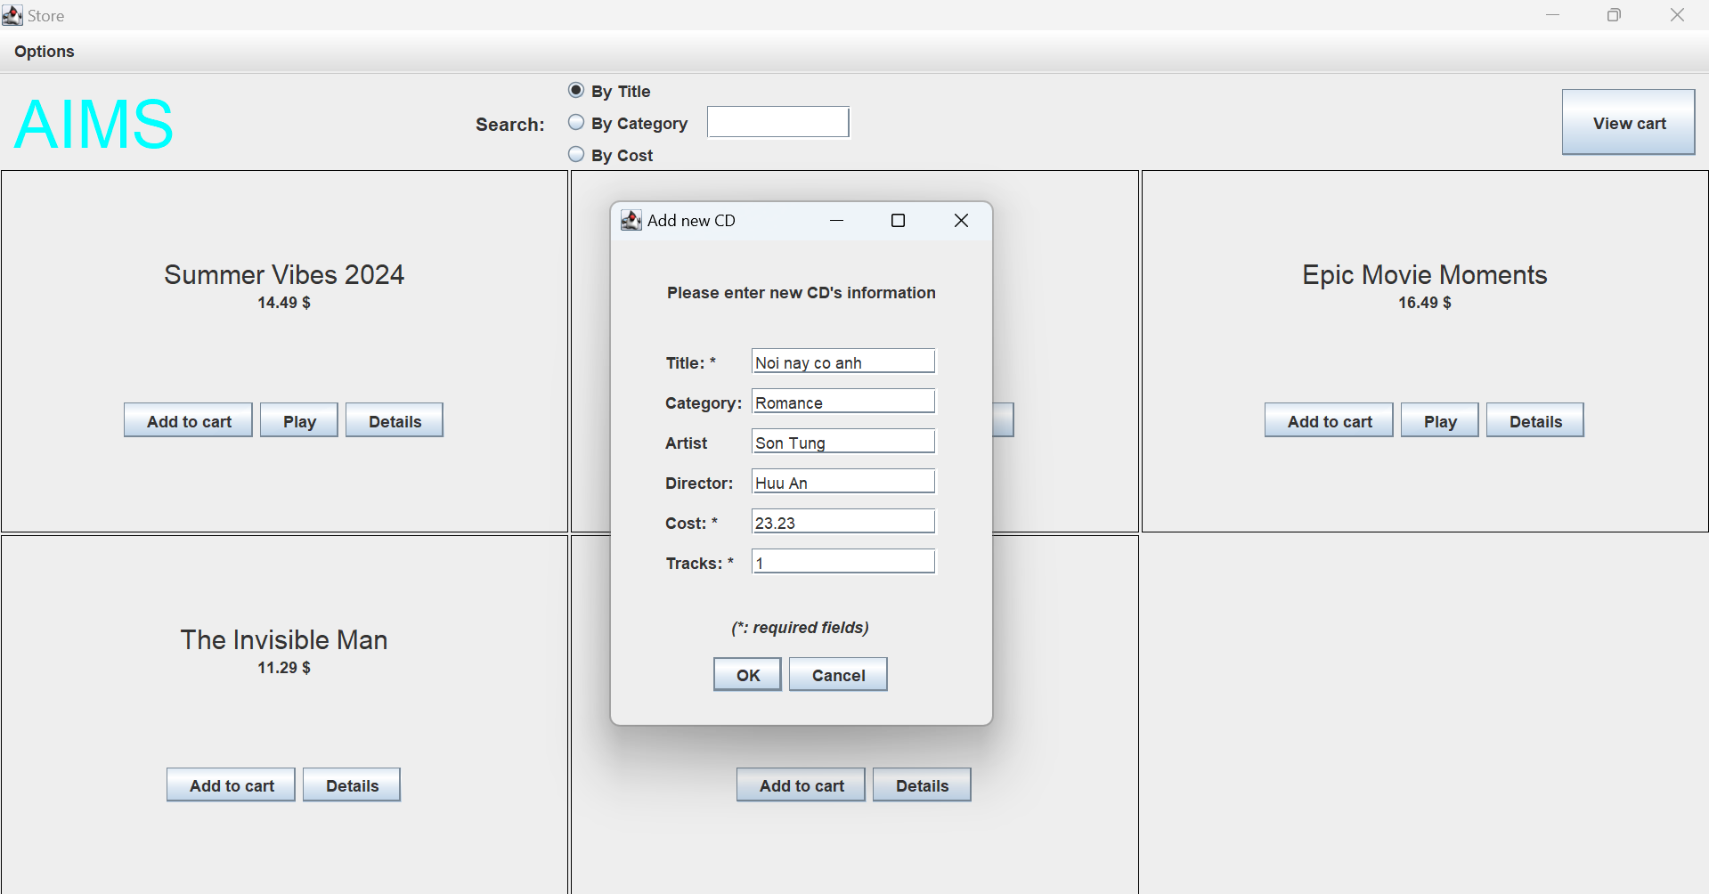

Figure : Add CD

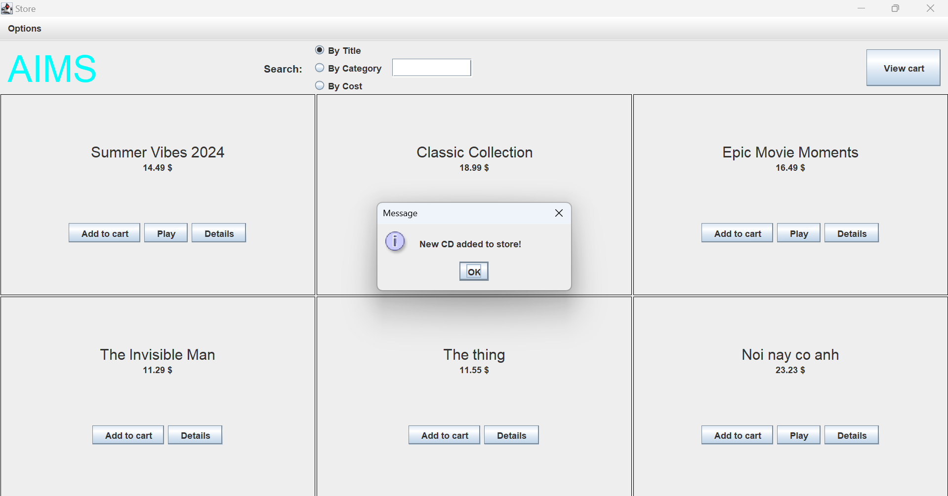

Figure : Store after add CD

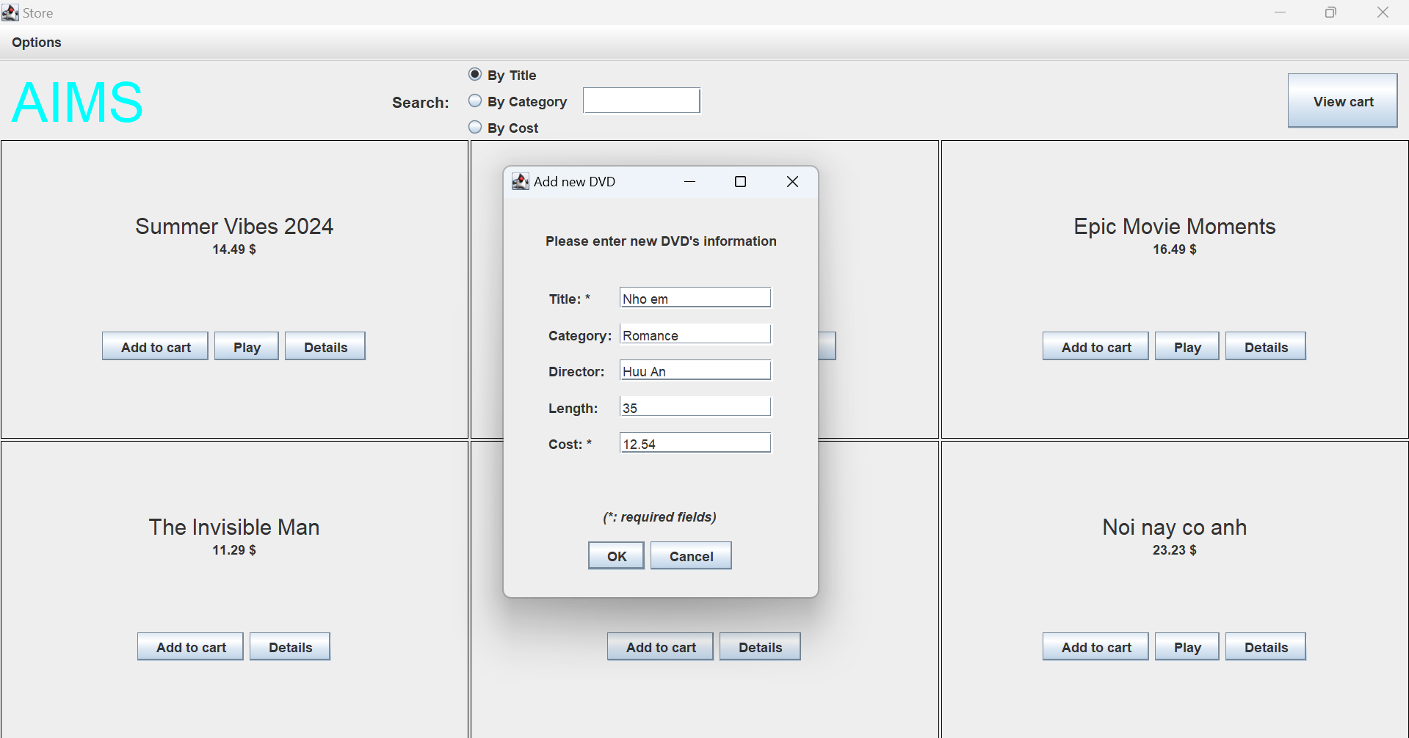

Figure : Add DVD

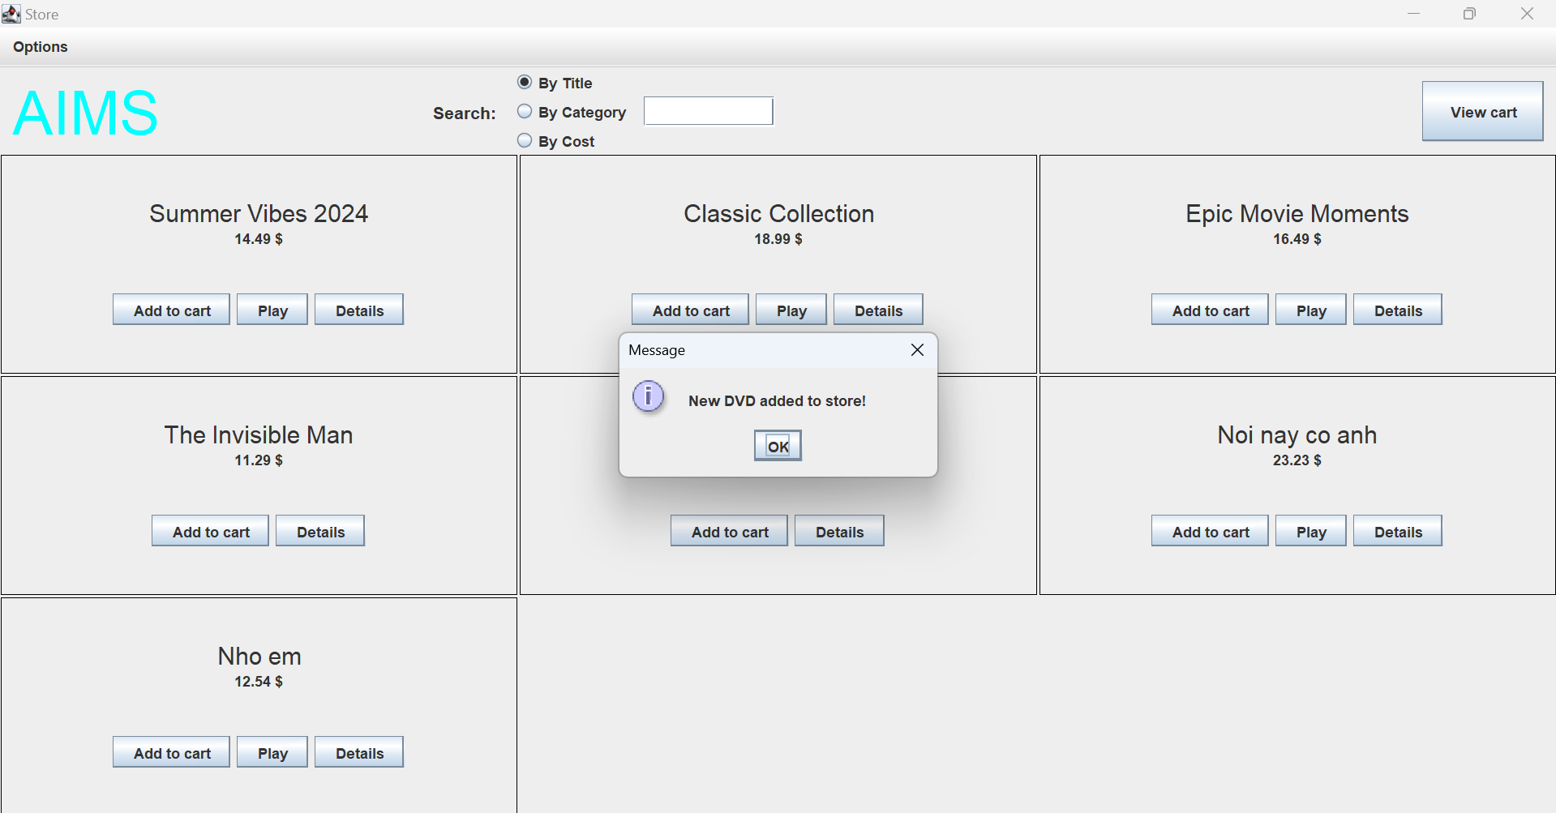

Figure : Store after add DVD

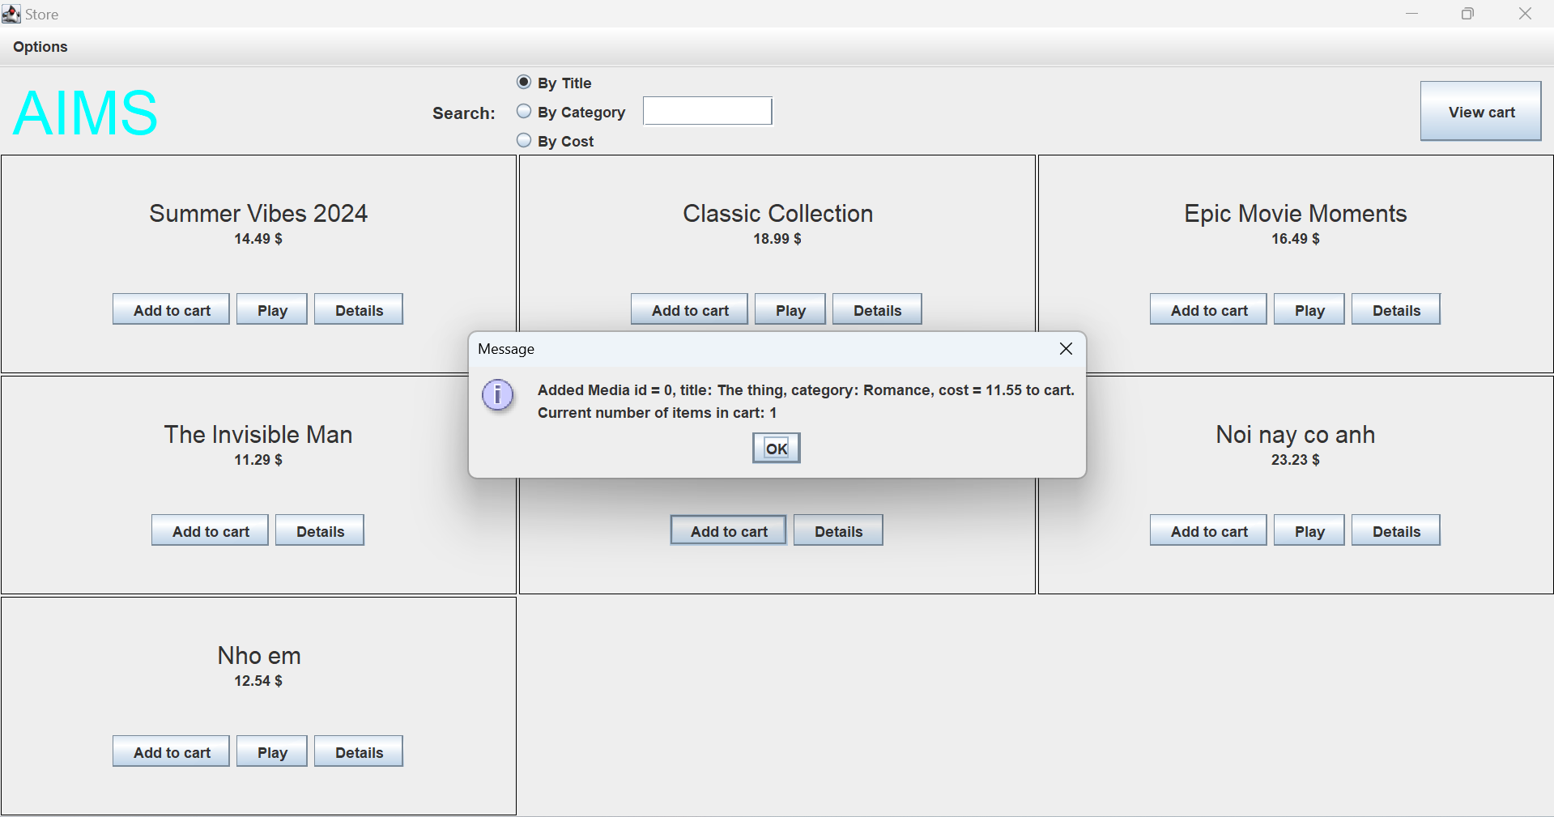

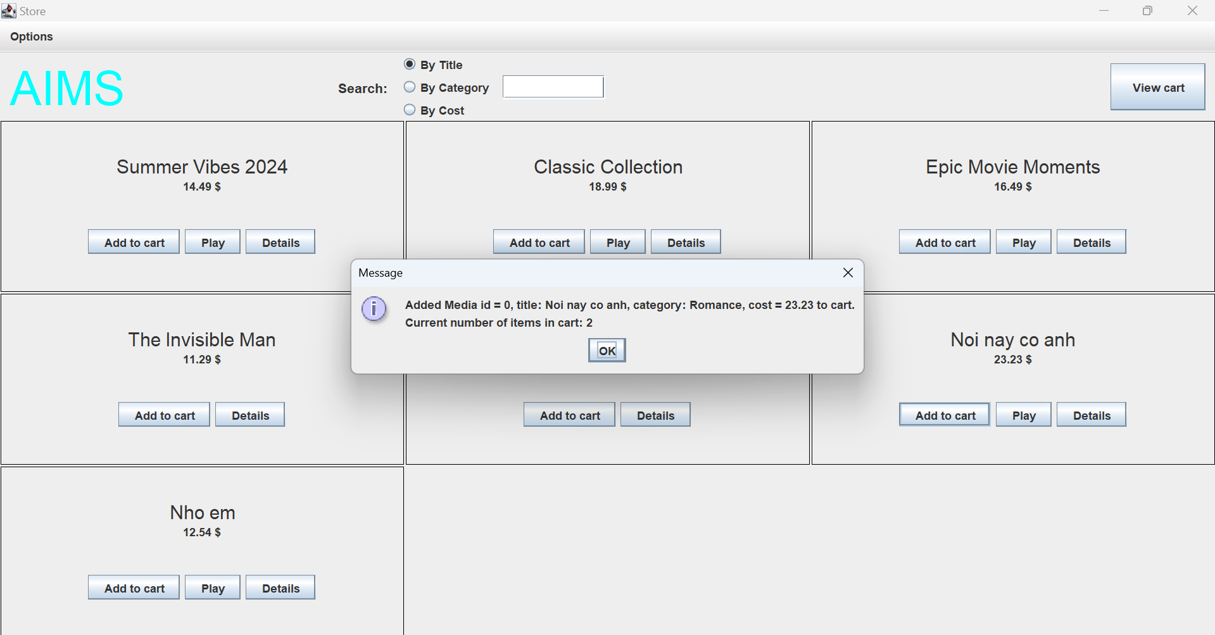

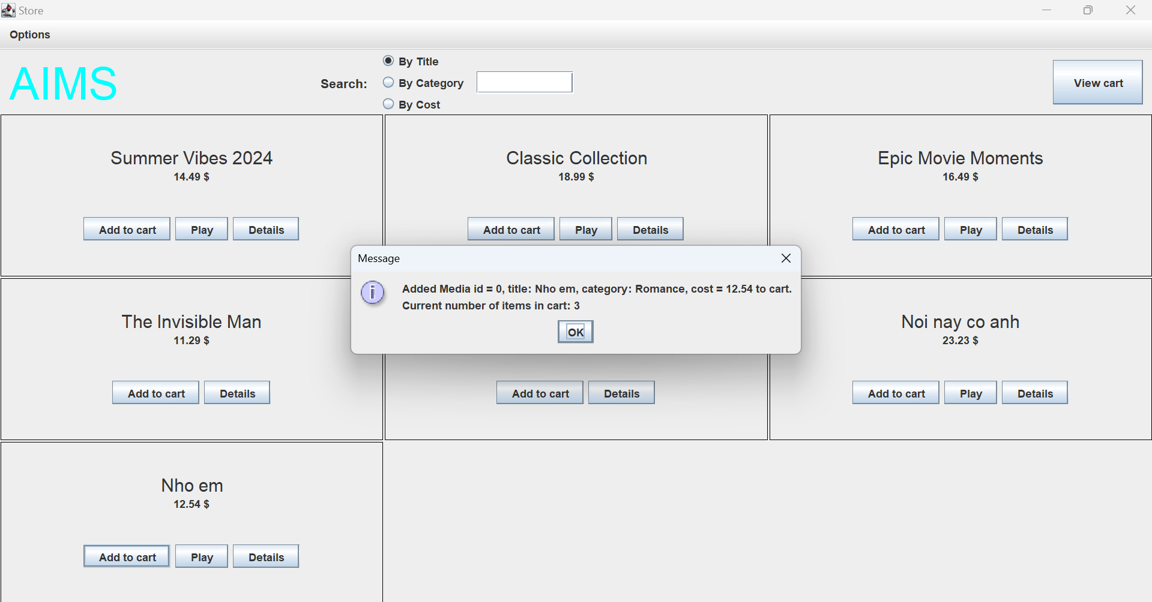

Figure : Add to Cart

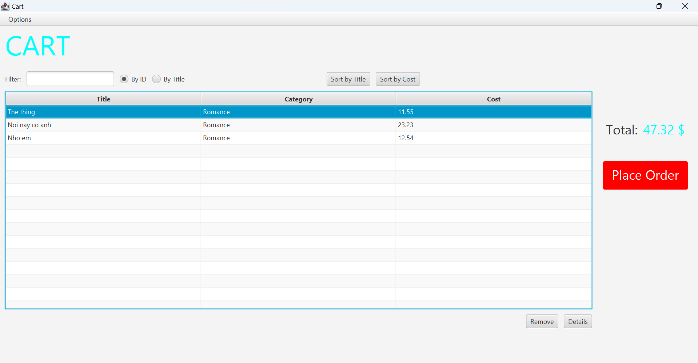

Figure : Cart

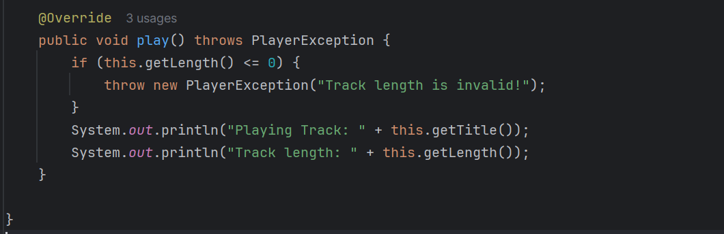

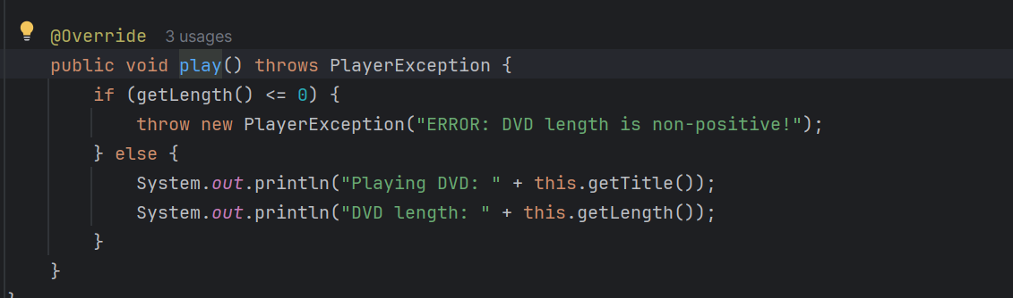

Figure : Exception

# Use case Diagram

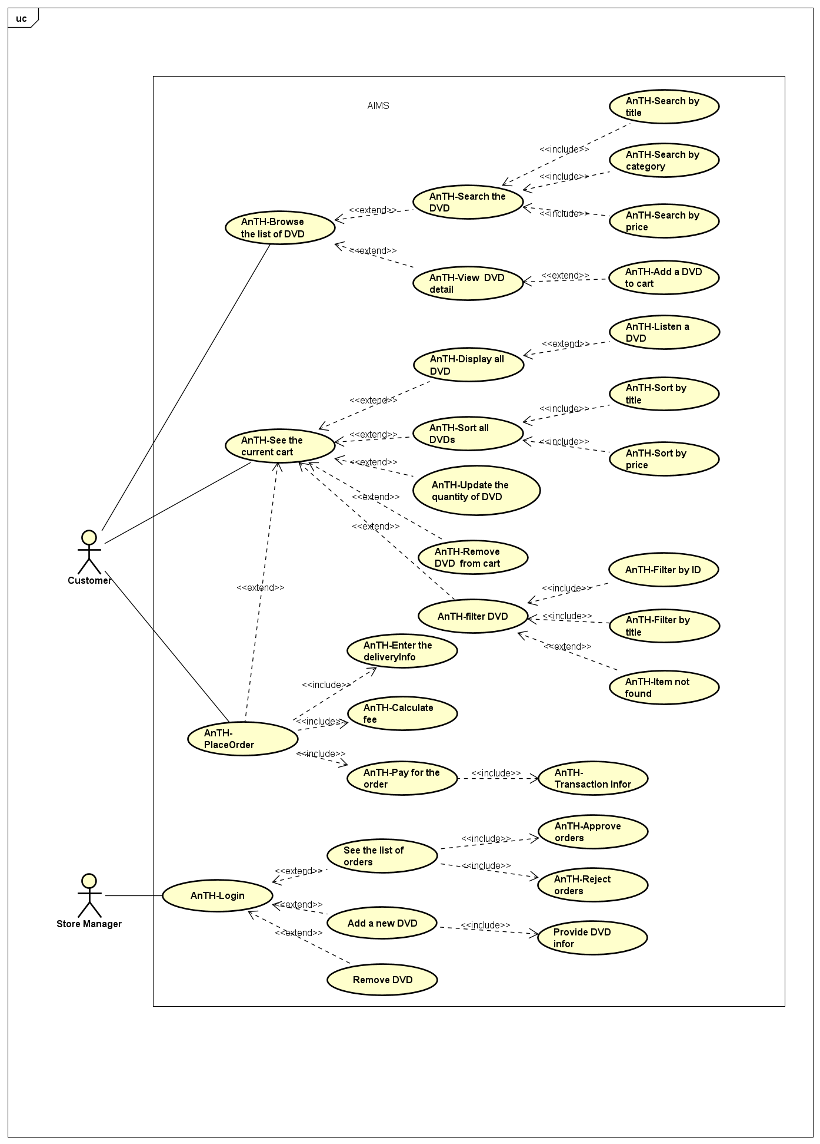

Figure : Use case diagram

# Class Diagram

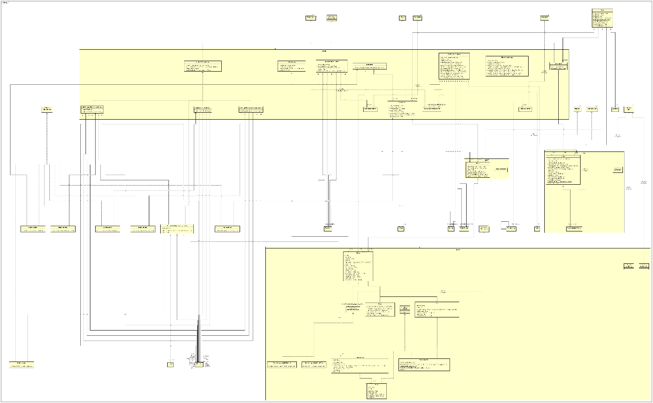

Figure : Class Diagram